EKS CLUSTER CREATION AND SETUP

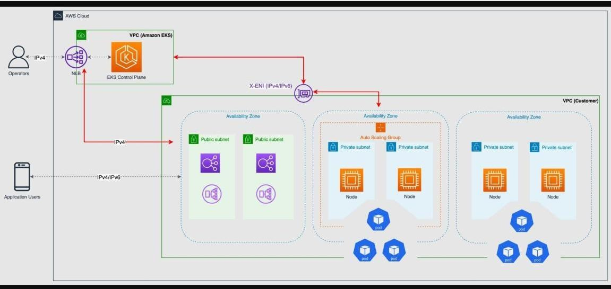

**EKS (Elastic Kubernetes Service) AWS** ka **managed Kubernetes service** hai. Ismein **AWS control plane** ko **manage** karta hai, tu sirf **pods** aur **worker nodes handle** karta hai.Yeh **secure**, **scalable** aur **production-ready** hota hai. **EKS** se tu bina tension ke **Kubernetes apps cloud** mein chala sakta hai

Yeh rahi step-by-step EKS Cluster creation ki guide Roman Urdu mein

# Part 1: EKS Cluster Creation and Setup-->(Stockholm Region Select Karo)

### Step 1: EKS Cluster Create Karna

1. **AWS Management Console** open karo.
2. Search bar mein "EKS" likho aur **Elastic Kubernetes Service**

open karo.

1. **Create Cluster** pe click karo. 4. **Cluster Configuration** mein:
   1. **Eks auto mode** disable karo.
   2. **Cluster Name**: Faisal enter karo --> (Aapka Name Likho)
   3. **Cluster IAM Role**: AmazonEKSClusterRole select karo.

YE KUCH ISTARHA LAGEGA

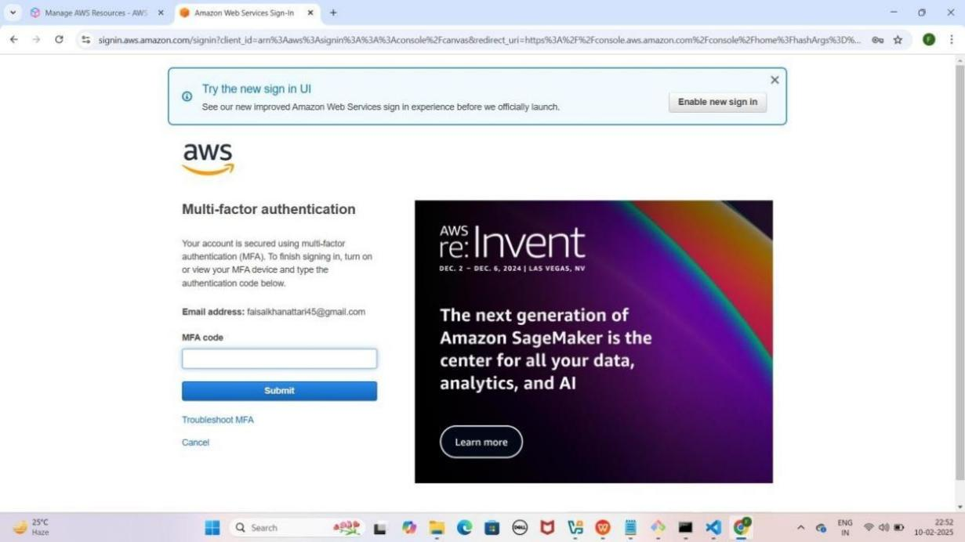

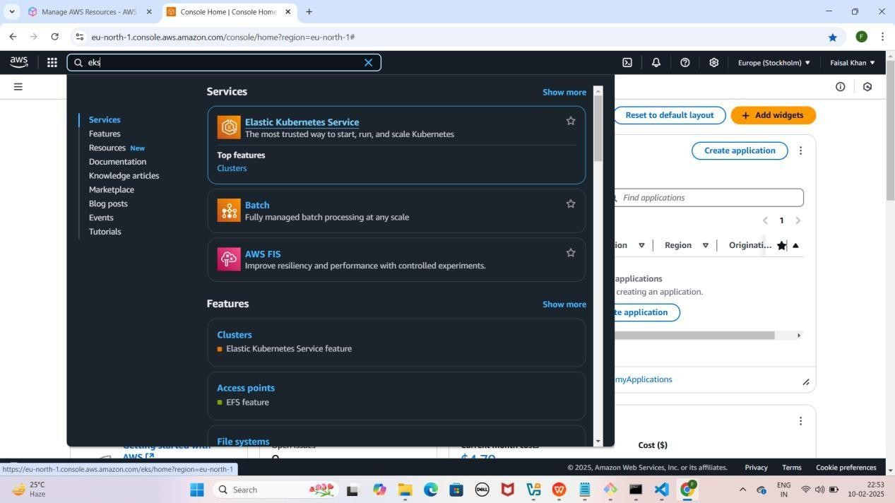

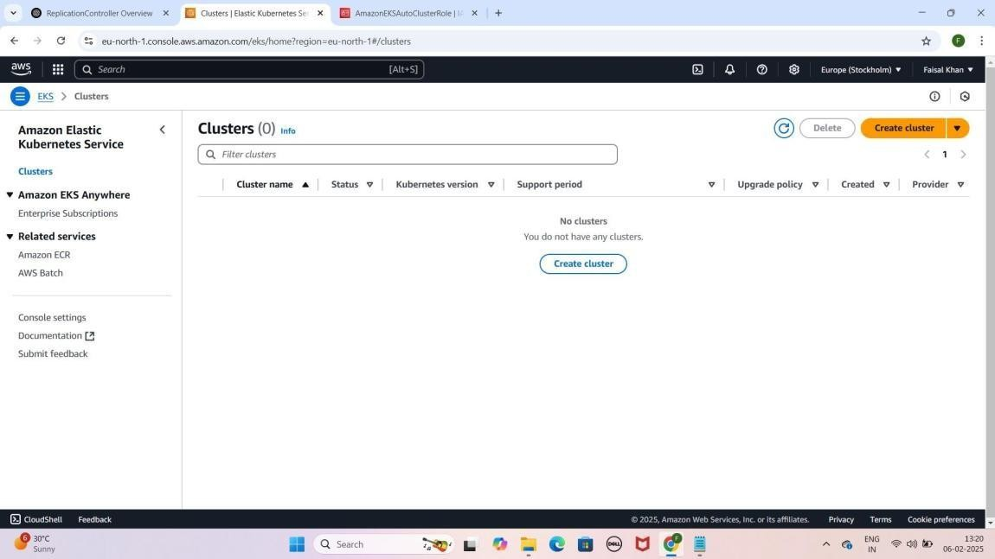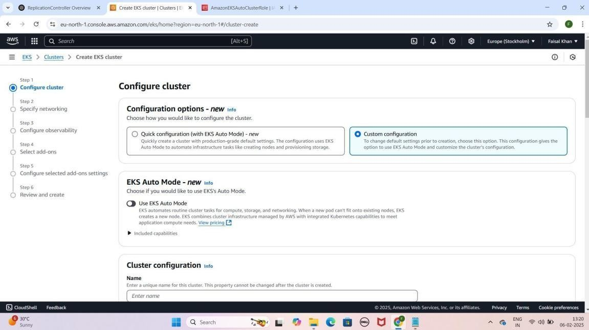

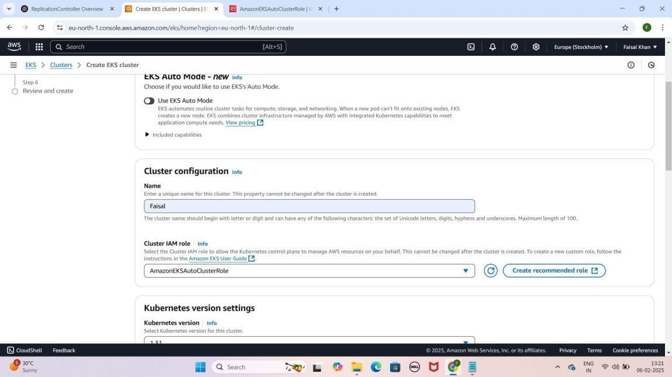

### Step 2: IAM Role Mein Additional Policies Attach Karna

1. **IAM Console** open karo (new tab mein).
2. **Roles** pe jao aur **AmazonEKSClusterRole search** karo.
3. **Attach Policies** pe **click** karo aur ye **policies** attach karo
   * **AdministratorAccess**
   * **AmazonEC2ContainerRegistryFullAccess**
   * **AmazonEC2FullAccess**
   * **AmazonEKSClusterPolicy**
   * **AmazonEKSComputePolicy**
   * **AmazonEKSLoadBalancingPolicy**
   * **AmazonEKSNetworkingPolicy**
   * **AmazonEKSWorkerNodePolicy**
   * **AmazonSSMManagedInstanceCore**
   * **EC2InstanceConnect**
4. **EKS Console** wapas jao, **AmazonEKSClusterRole** ko **select**

karo

YE KUCH ISTARHA LAGEGA

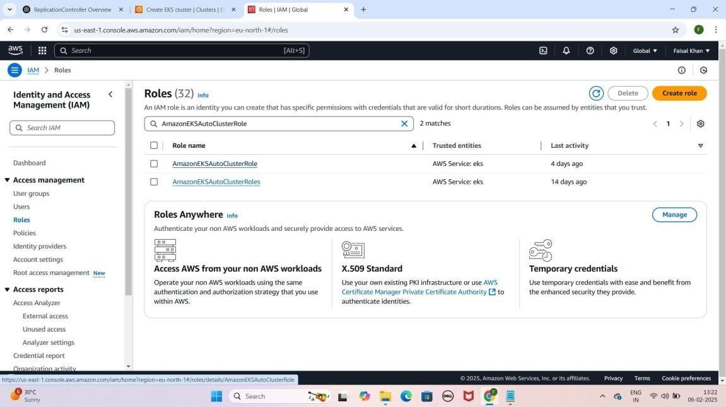

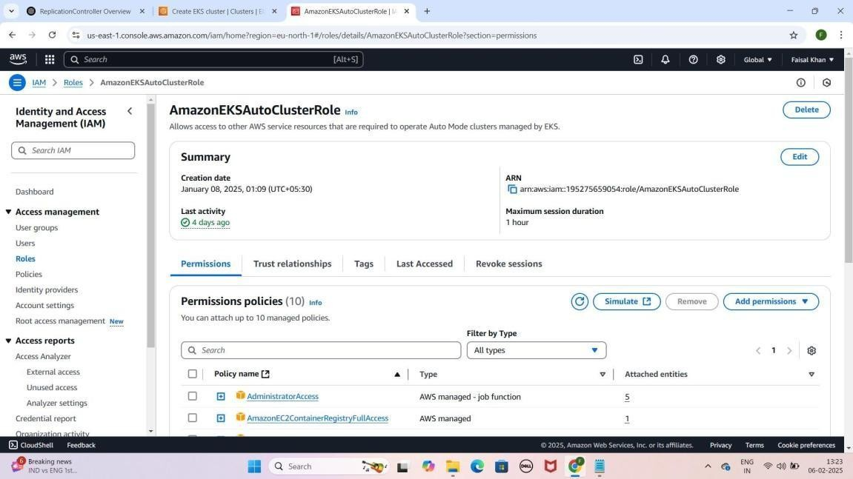

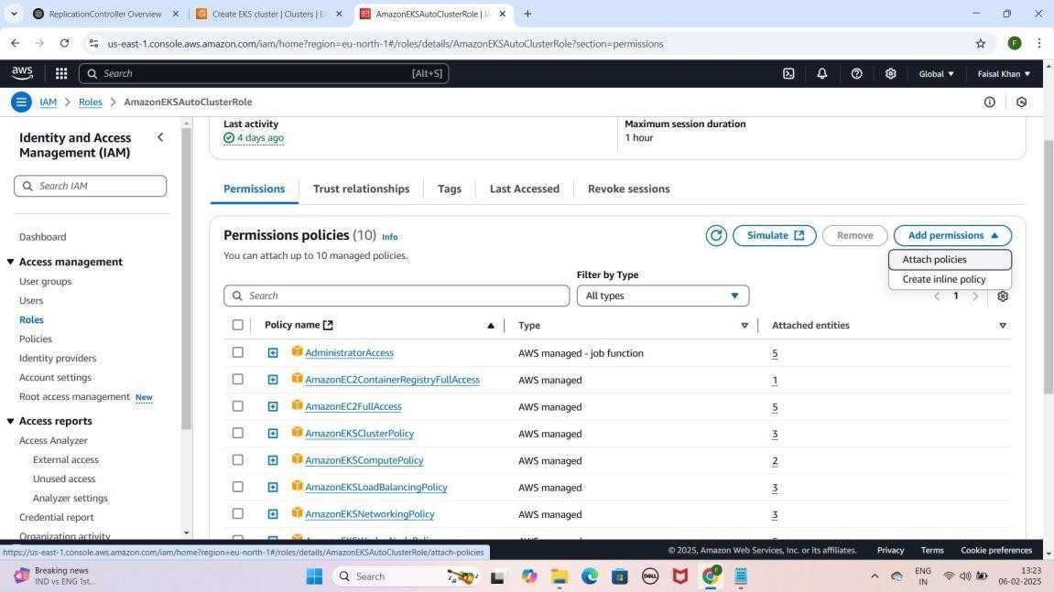

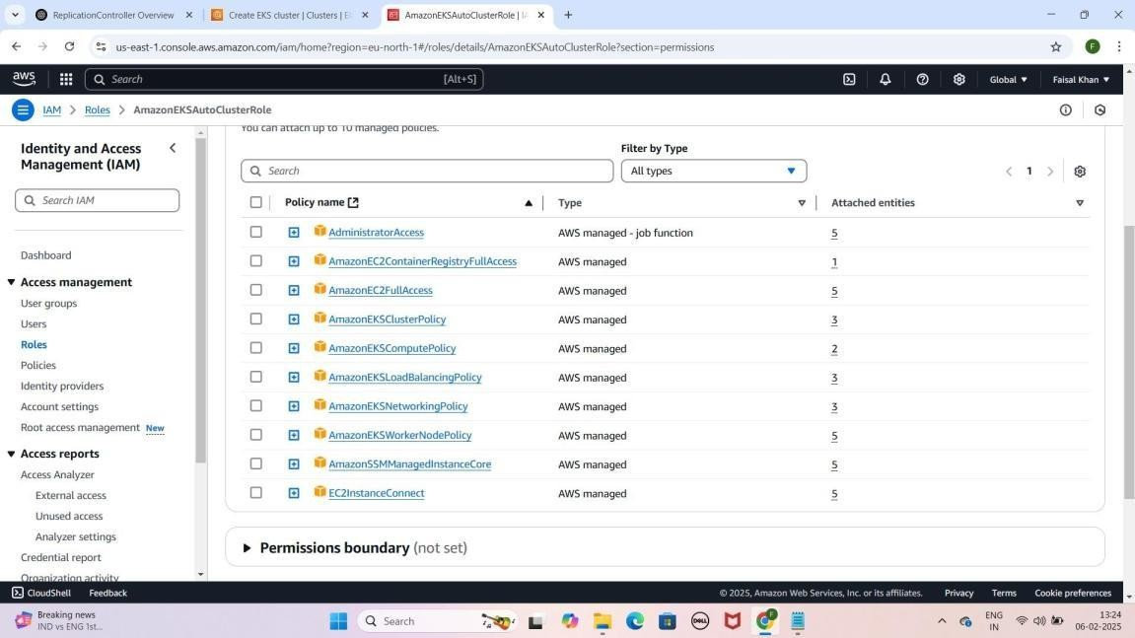

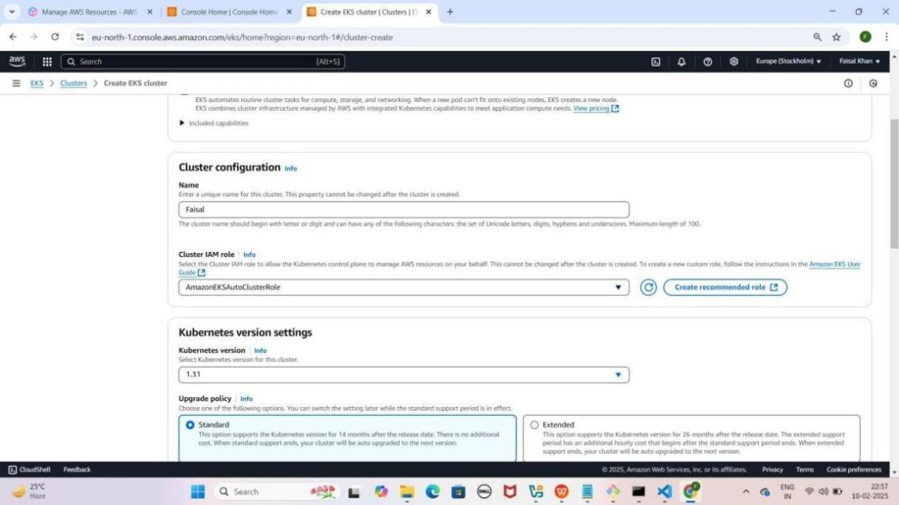

### Step 3: KMS Key Banana (Secrets Encryption Enable Karna)

1. **KMS Console** open karo (new tab mein).
2. **Create Key** pe **click** karo.
3. **Alias Name**: **Faisal-Keys** enter karo --> (Aapka Name Likho)
4. **IAM Roles**: **AmazonEKSClusterRole** aur

AmazonEKSNodeRole select karo.

1. **Key Users**: **Same roles** select karo.
2. **Next** → **Next** → **Review** page pe **Finish** pe **click** karo.
3. **Wapas EKS Console** jao, **KMS Key** select karo jo abhi **create** ki.

YE KUCH ISTARHA LAGEGA

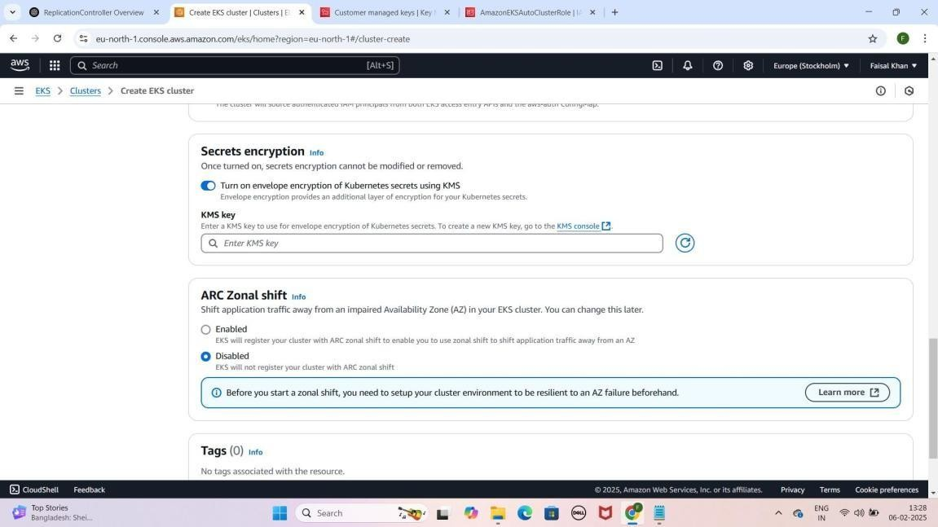

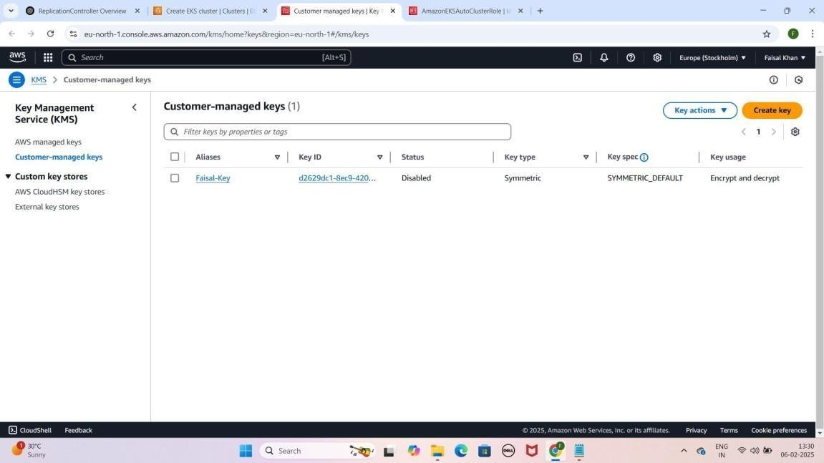

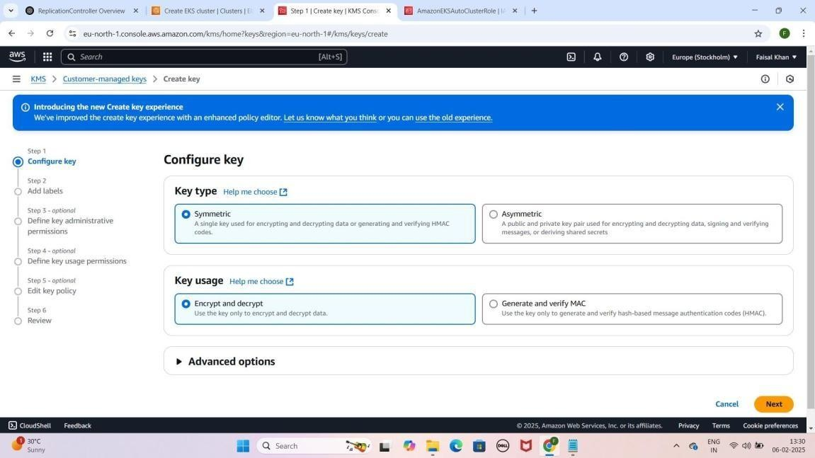

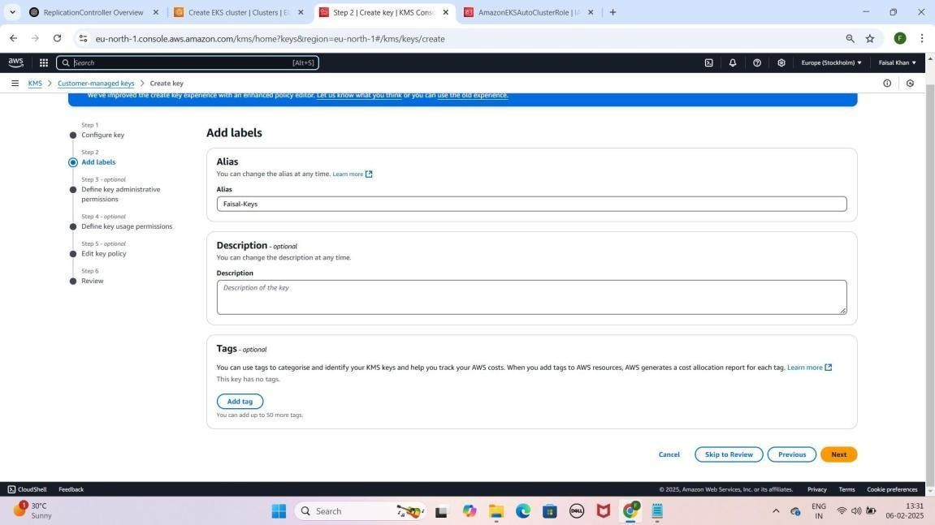

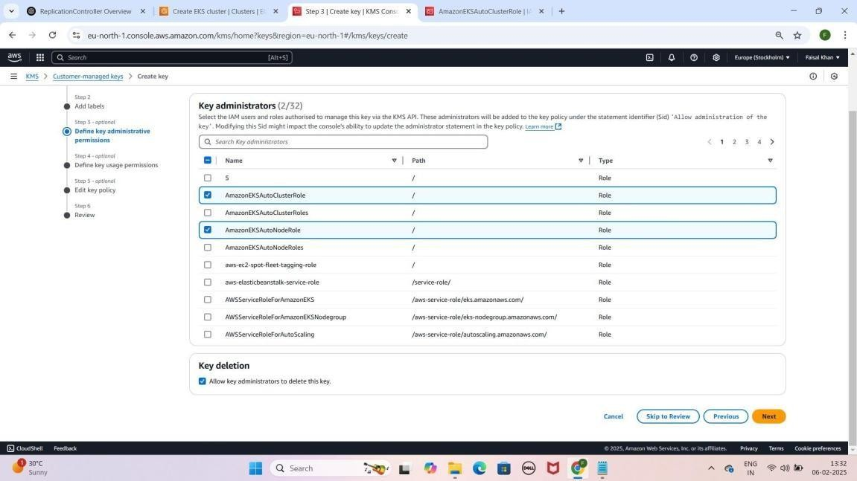

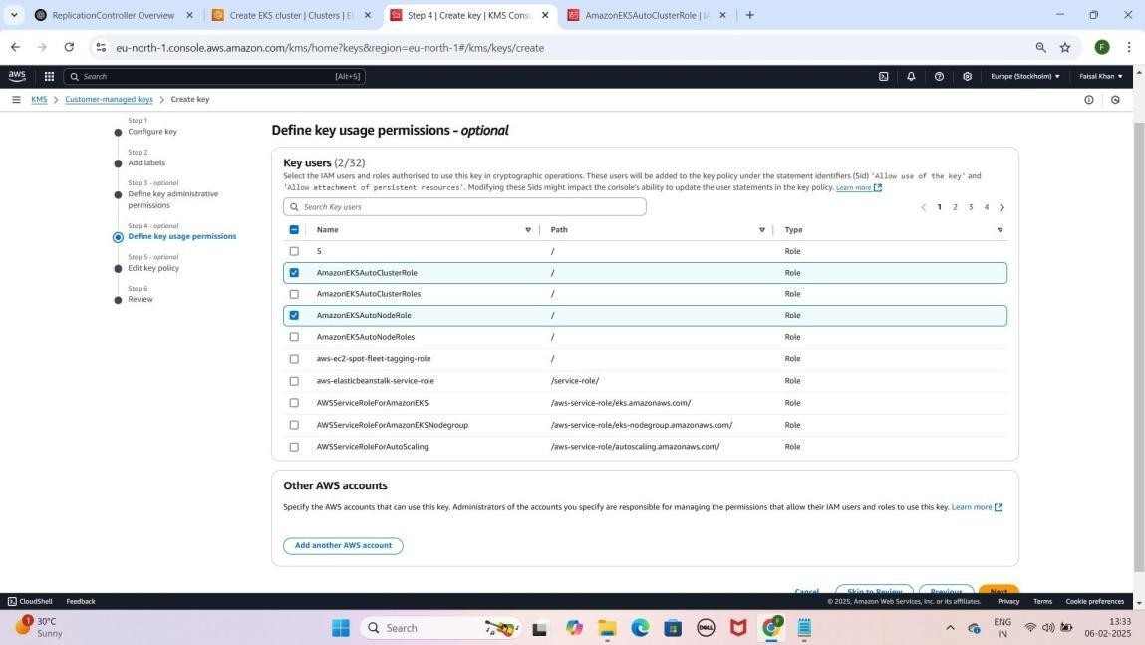

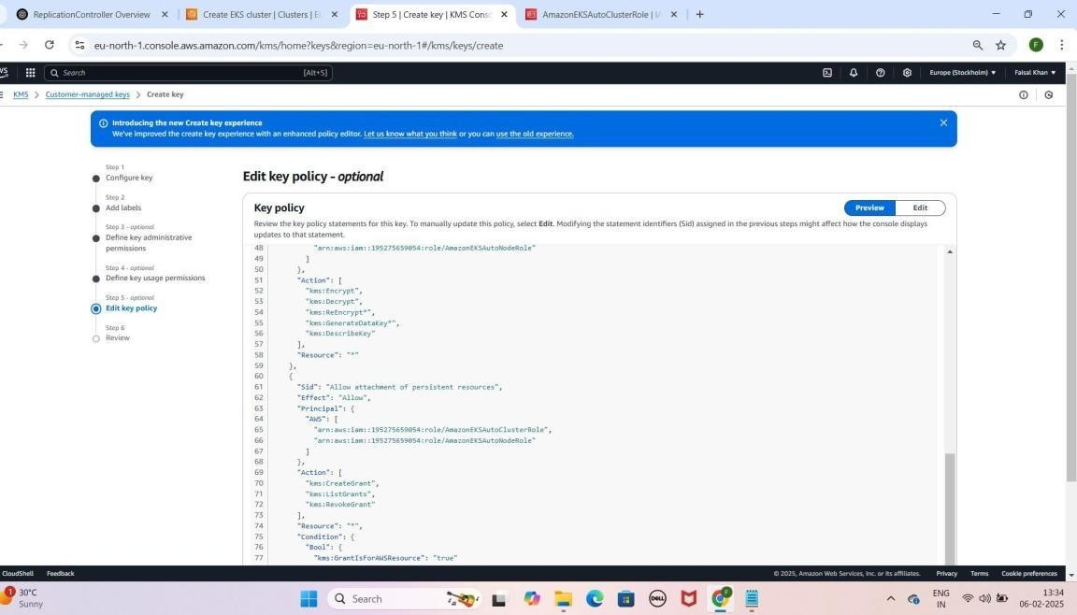

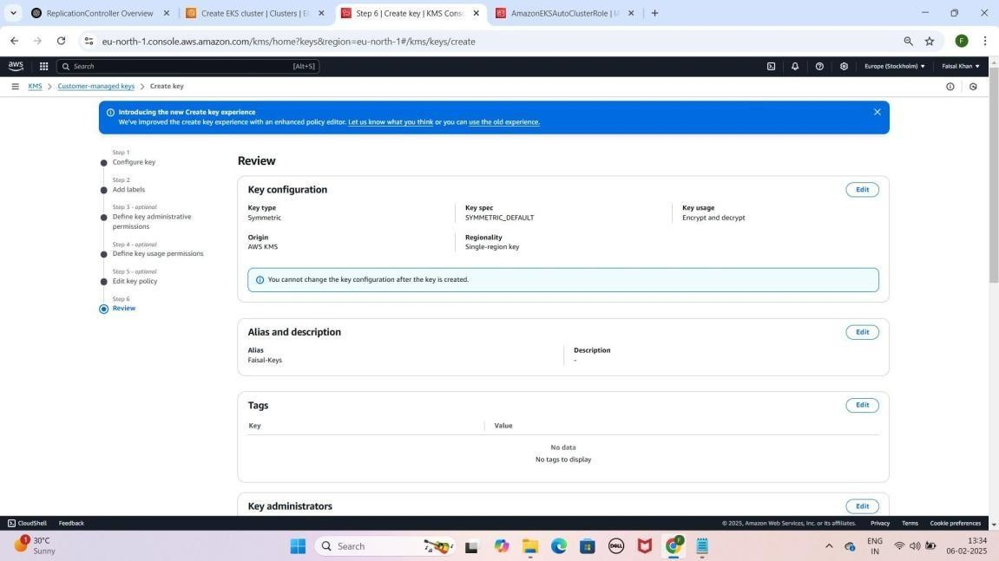

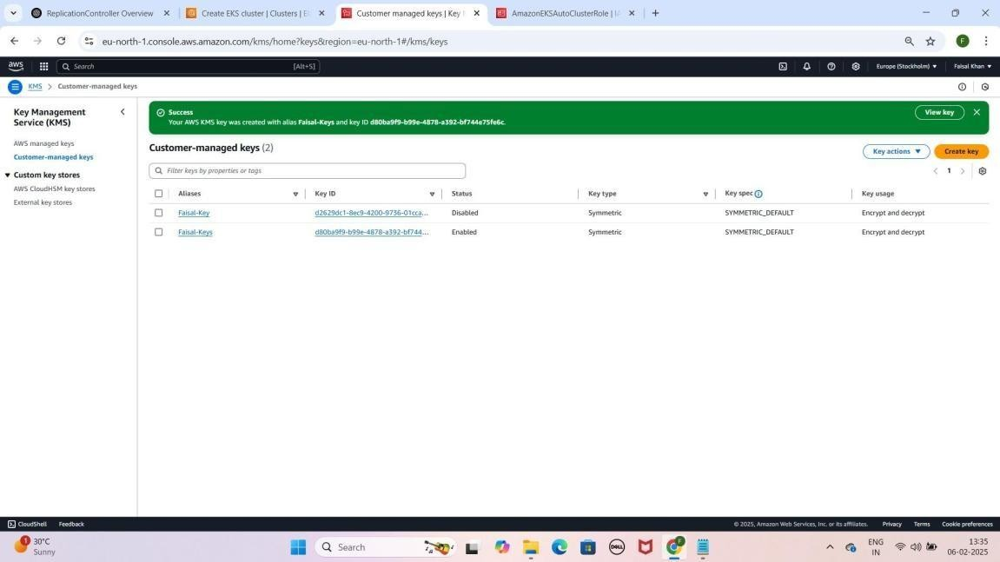

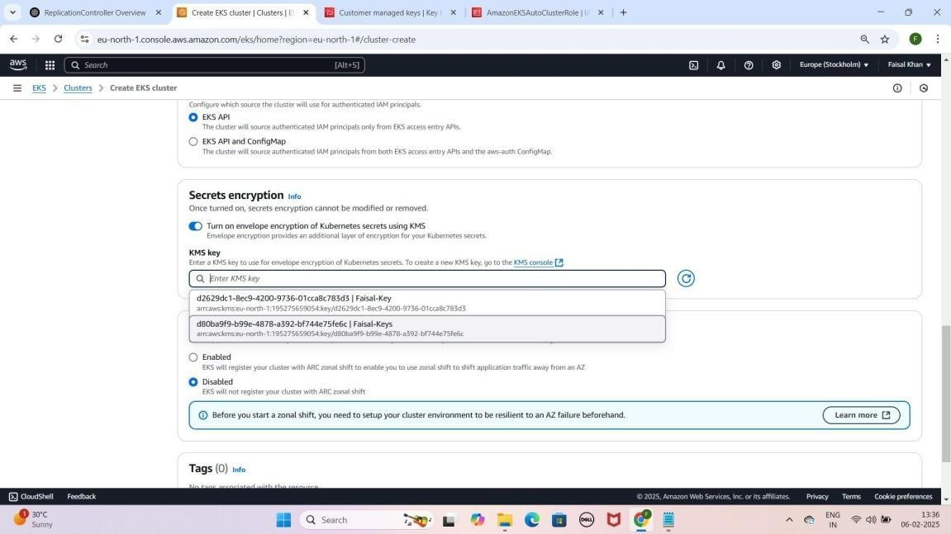

### Step 4: Security Group Create Karna

1. **EC2 Console** open karo.
2. **Security Groups** section mein jao.
3. **Create Security Group** pe click karo.
   1. **Name**: ALL-TRAFFIC-ALLOW
   2. **Description**: My all traffic security group
4. **Inbound Rules**
   1. **Type**: All Traffic 2. **Source**: Anywhere IPv4
5. **Outbound Rules**
   1. **Type**: All Traffic
   2. **Destination**: Anywhere IPv4
6. **Create Security Group** pe click karo.
7. Wapas **EKS Console** jao aur **ALL-TRAFFIC-ALLOW** security group select karo.

YE KUCH IS TARHA LAGEGA

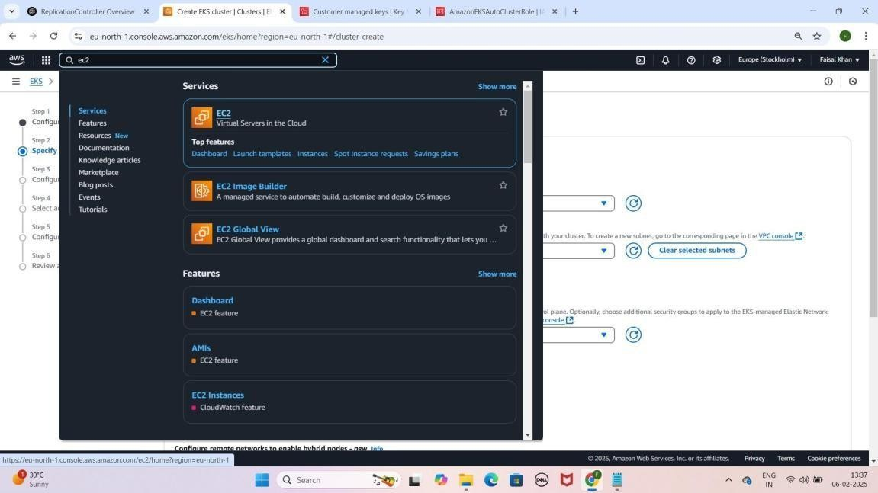

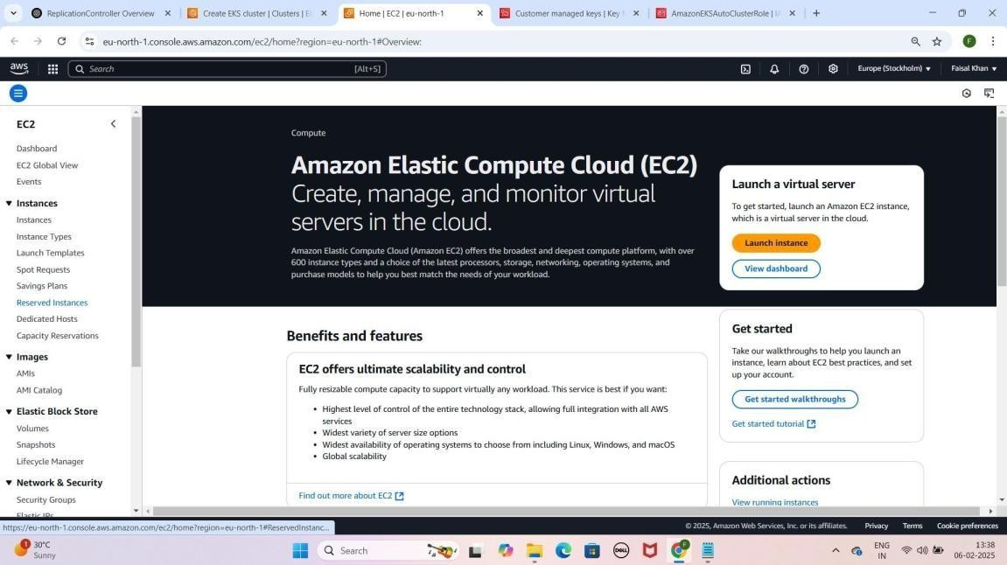

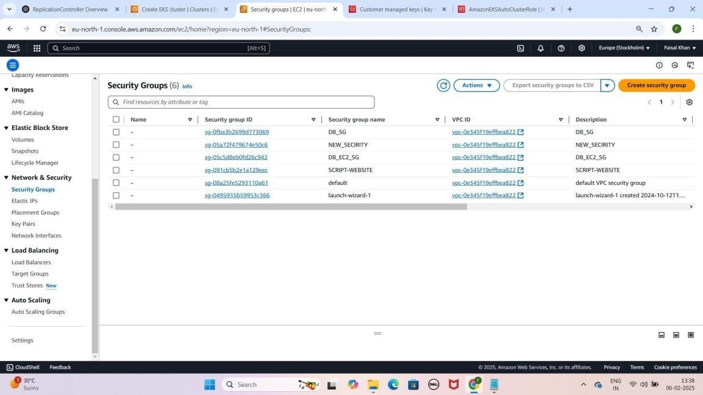

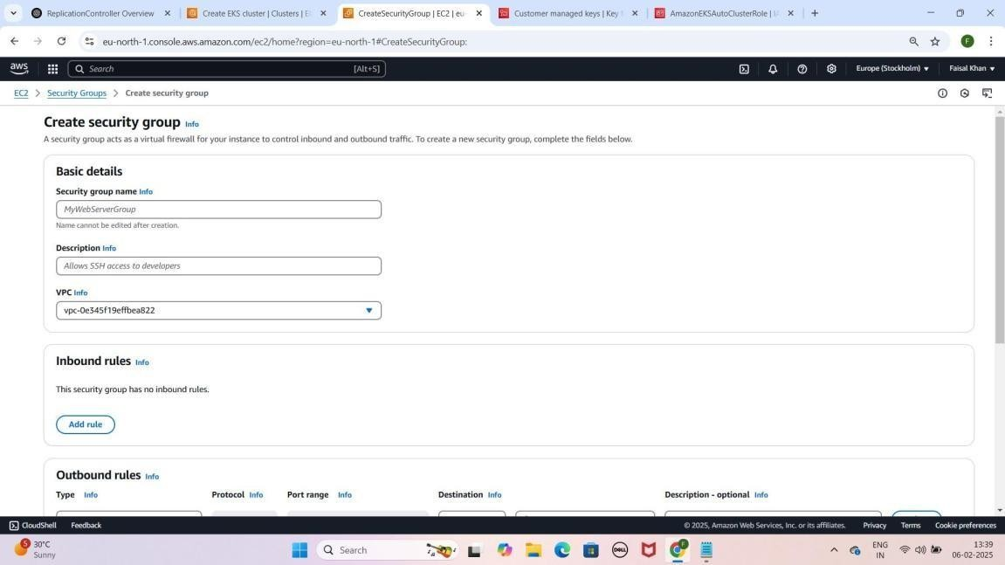

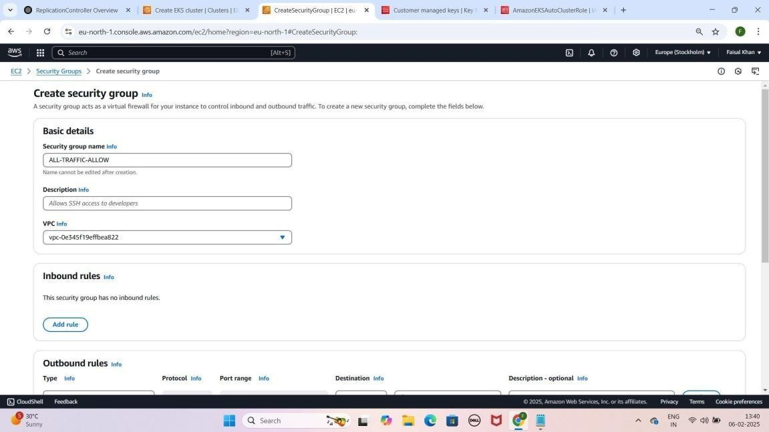

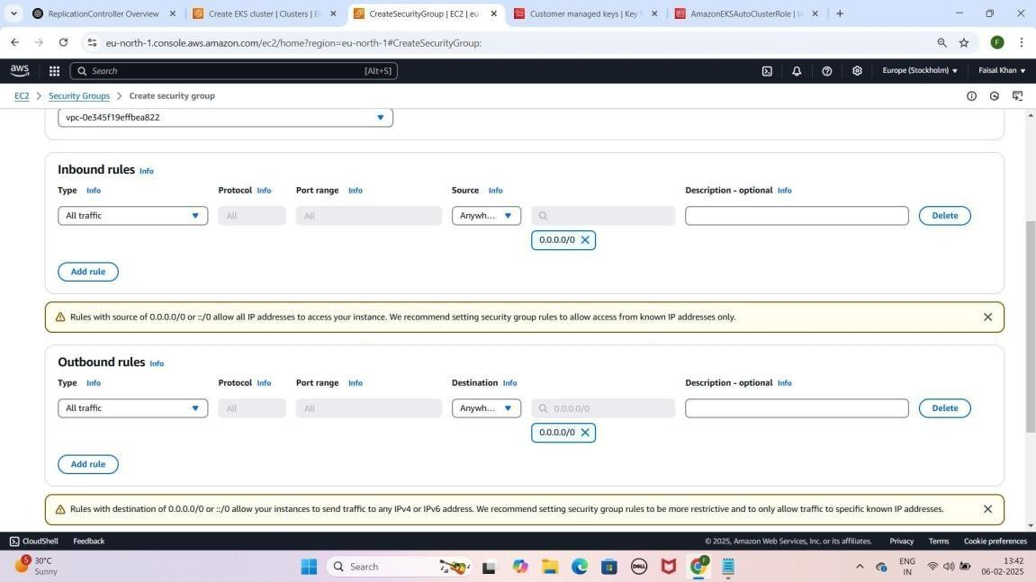

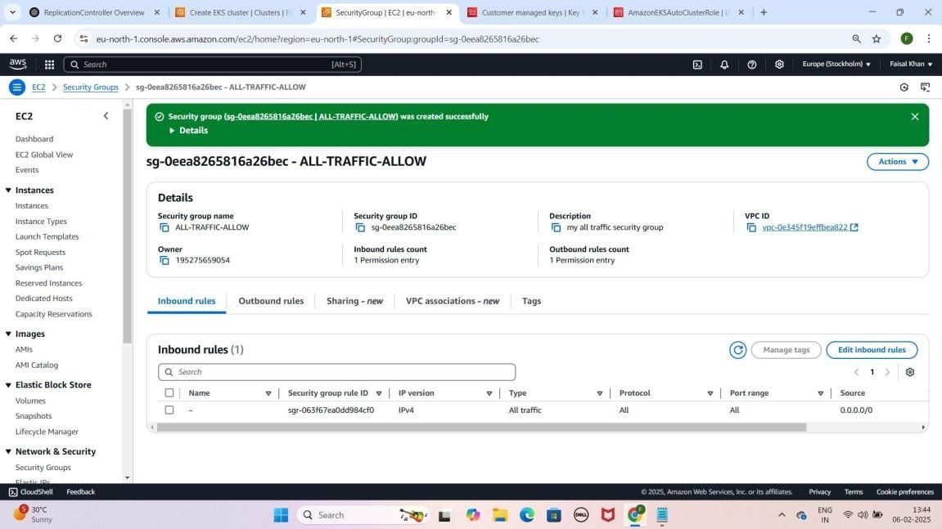

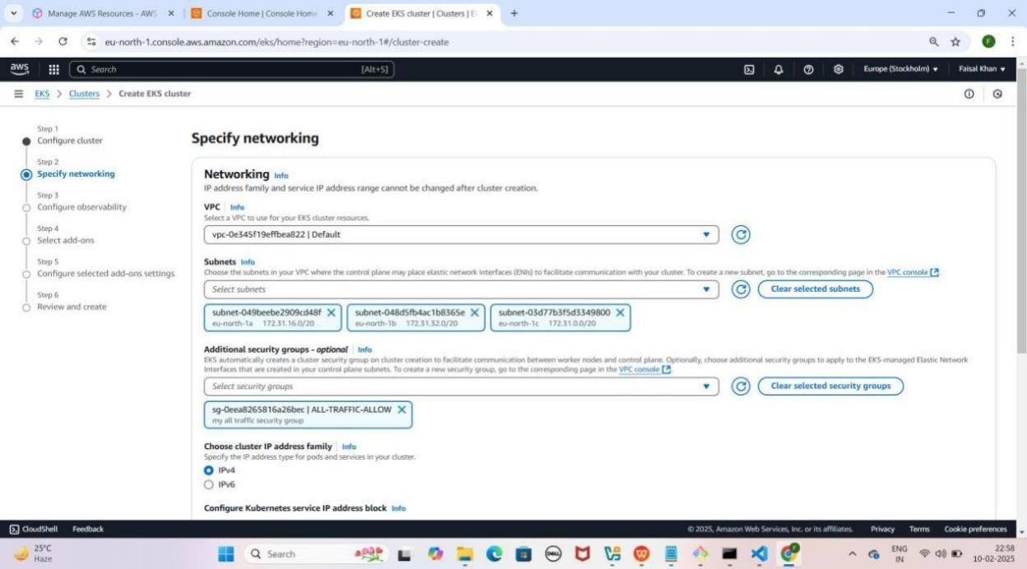

### Step 5: Observability Configure Karna

1. **"Configure observability" section** mein
2. **"Control Plane Logs" enable karo**
3. 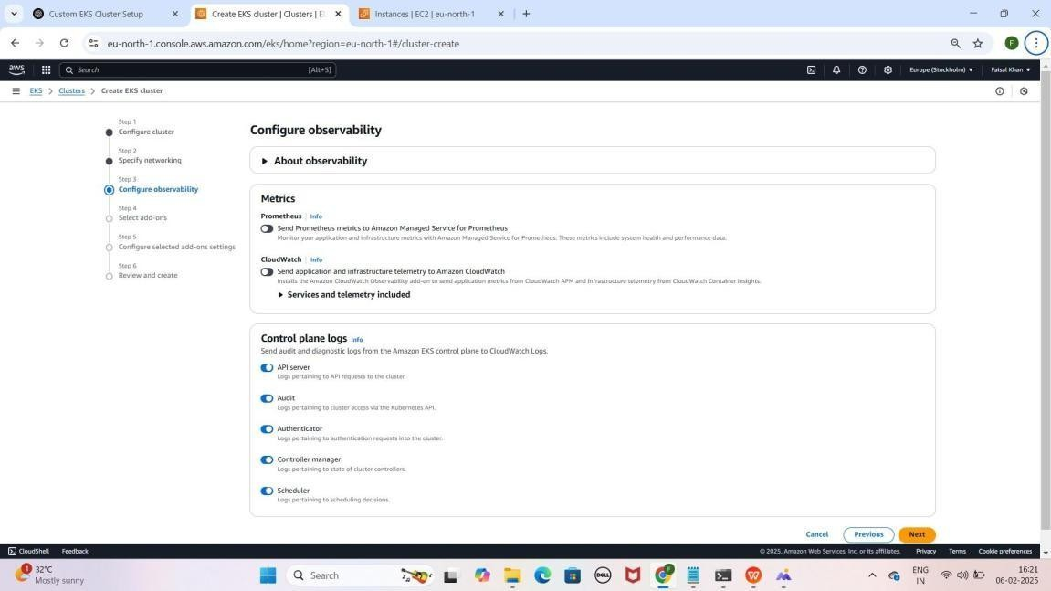**Next** pe click karo YE KUCH ISTARHA LAGEGA

### Step 6: Add-ons Configure Karna

* 1. **"Select add-ons" section** mein kuch **default** selected **add-ons**

honge, unko waise hi rehne do

* 1. 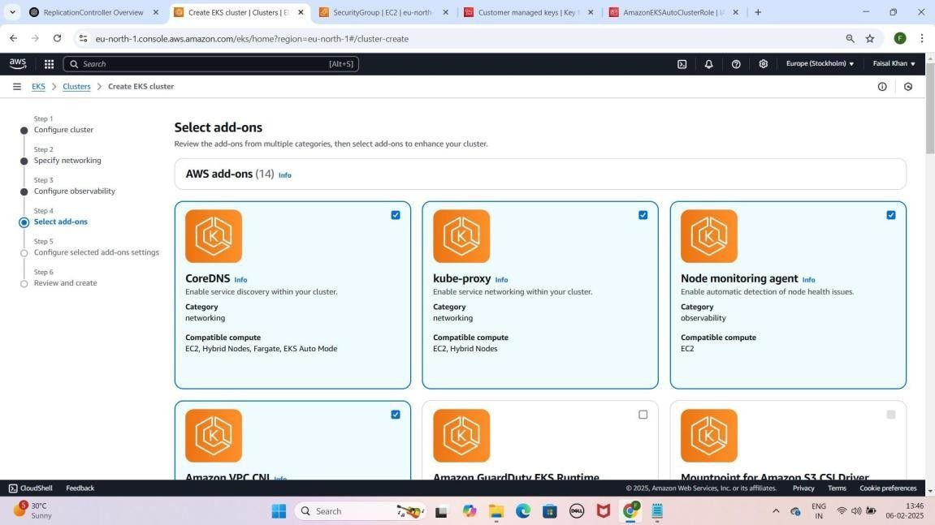**Next** pe **click** karo YE KUCH ISTARHA LAGEGA

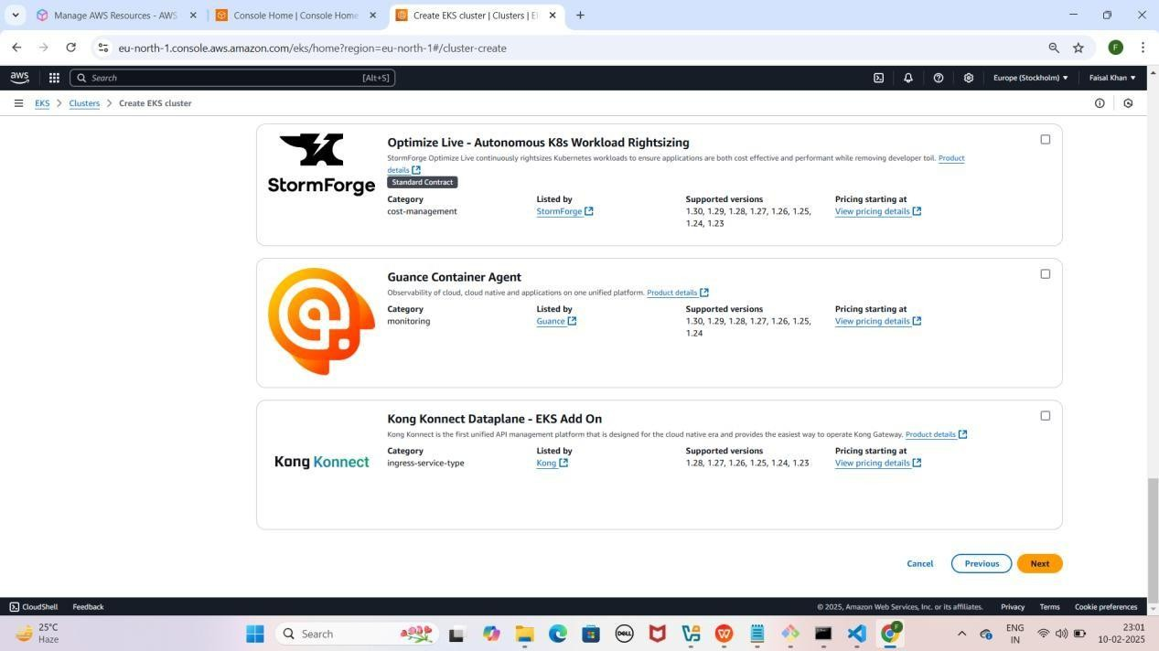

### Step 7: Control Plane Logs Enable Karne ke baad

1. **All Control Plane Logs** enable karne ke baad.
2. **Amazon VPC CNI** section mein jao, **Create Recommended Role** pe click karo.
3. **Use Case**: EKS pre-selected hoga.
4. **Attach Policies**:
   1. **AdministratorAccess**
   2. **AmazonEKS_CNI_Policy**
5. **Role Name**: PODS-ROLE
6. **Create Role** pe click karo.
7. Wapas **EKS Console** jao, **Amazon VPC CNI** ke liye PODS-ROLE select karo.
8. **Review & Create** karo, phir **Create Cluster** pe click karo.

## YE KUCH ISTARHA LAGEGA

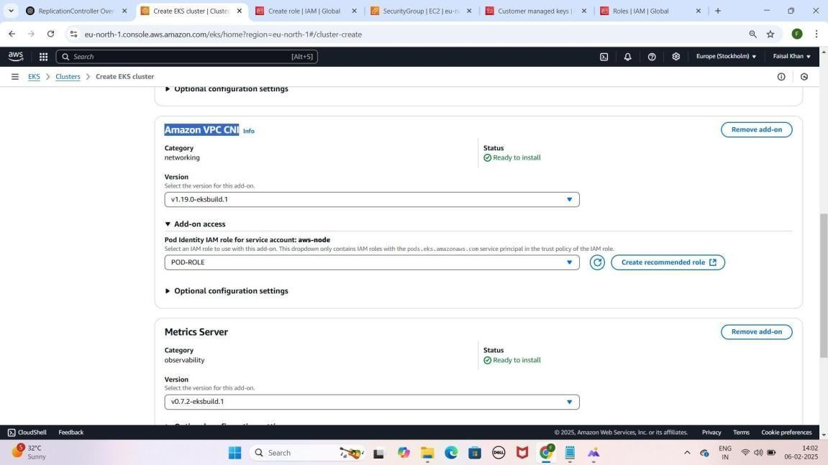

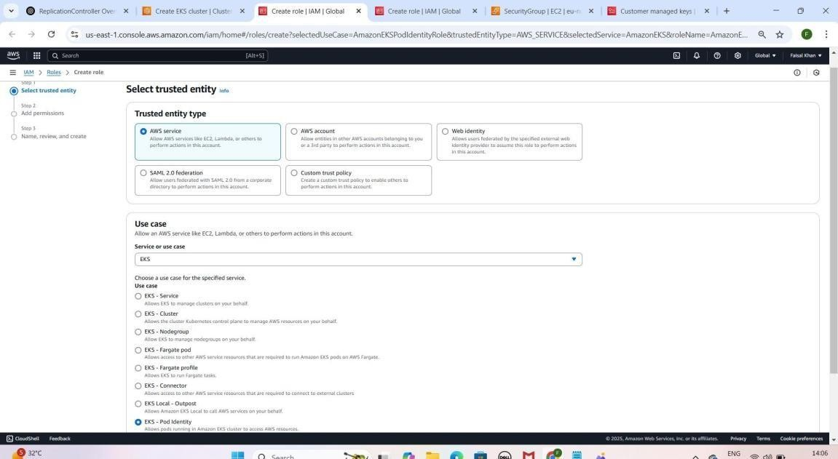

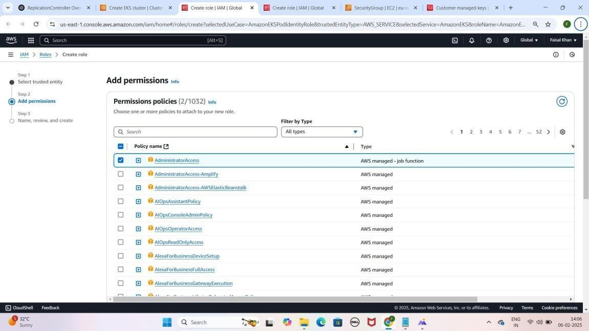

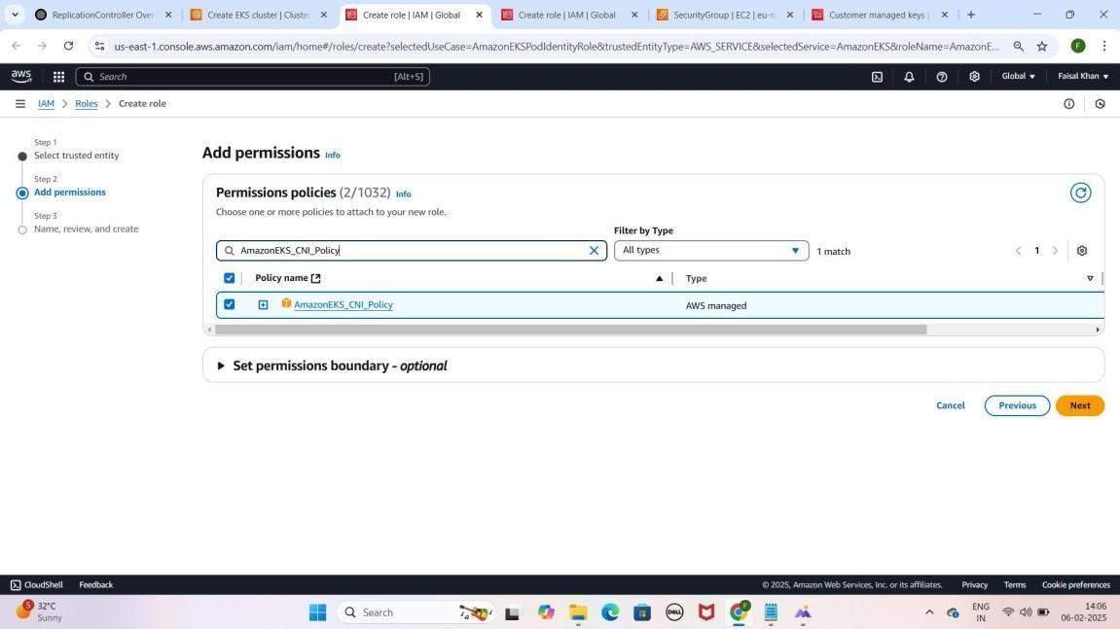

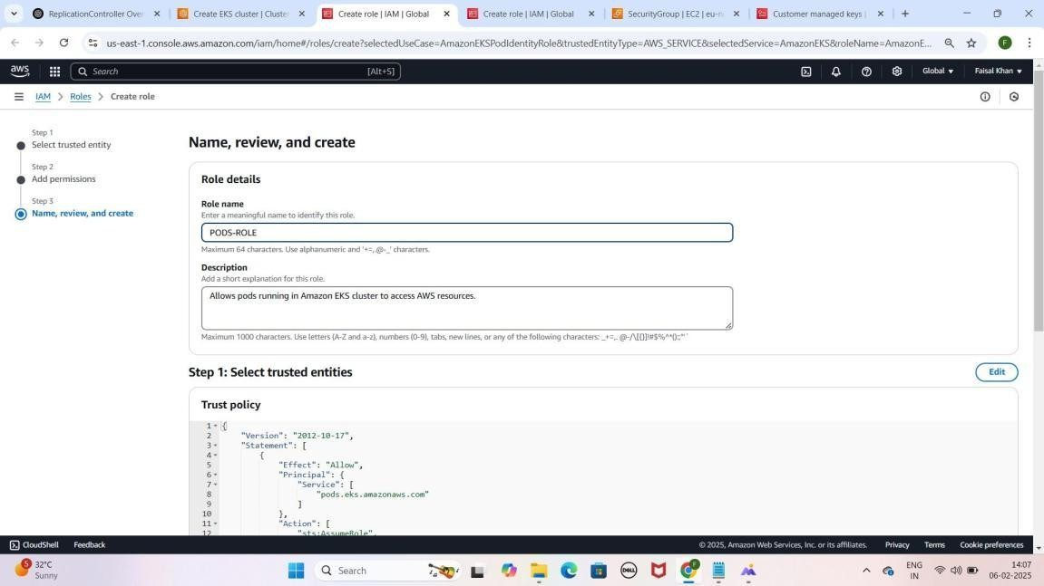

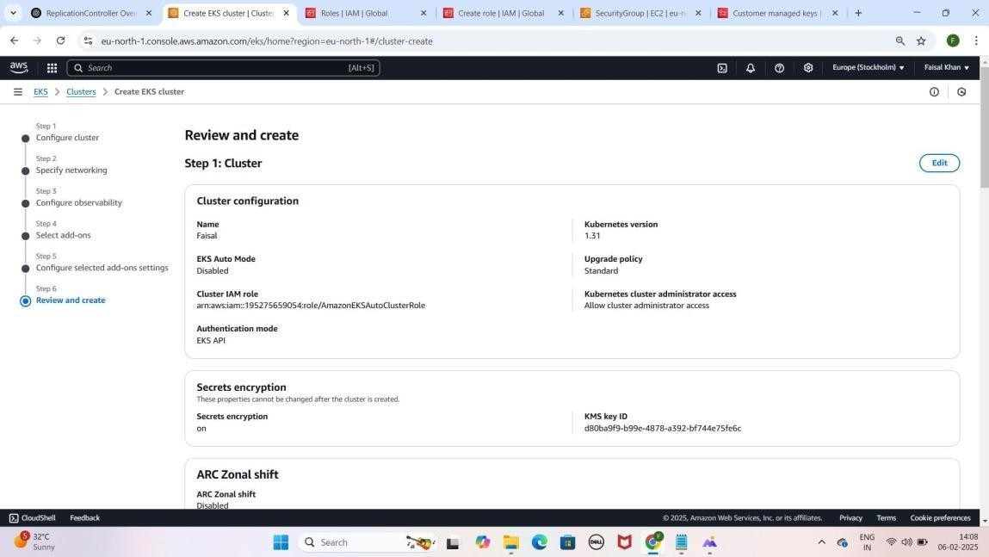

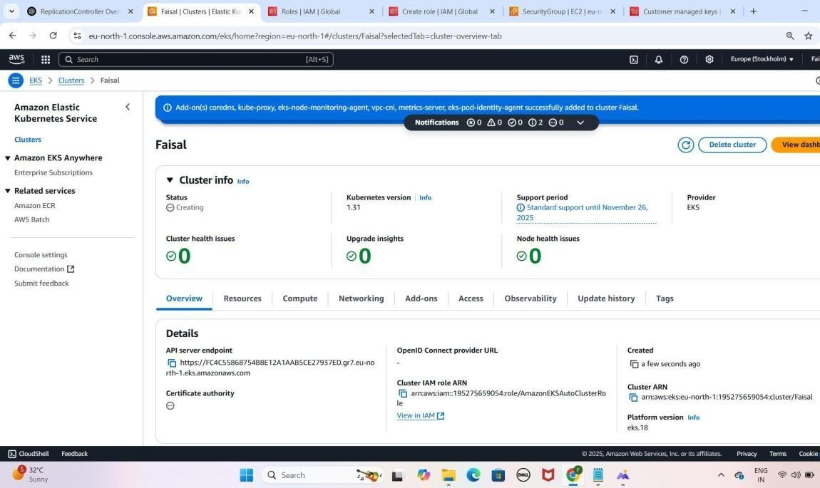

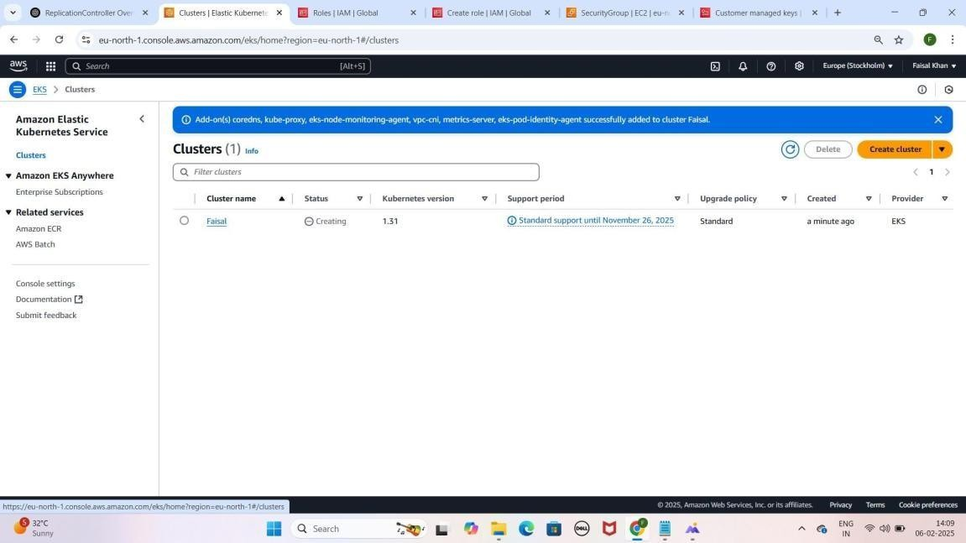

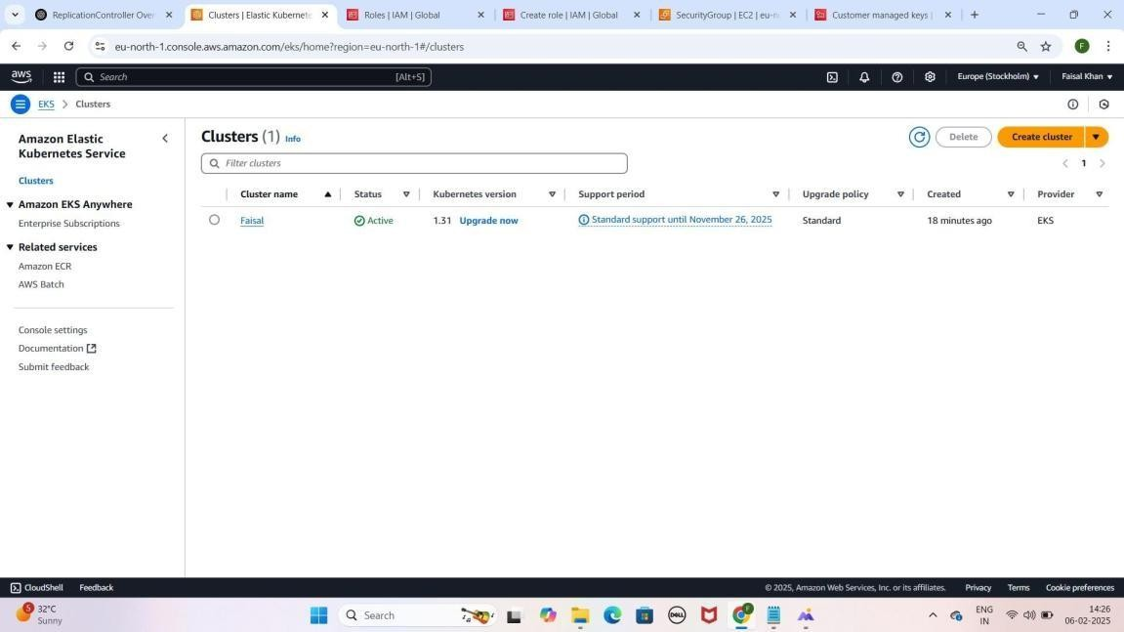

NOTE: Ab 15–20 minutes ka wait karein, aur har 5 minute baad page refresh karte rahein. Aapka cluster jaldi active ho jayega.

### Step 8: Node Group Create Karna

1. **EKS Console** pe jao, **cluster select** karo.
2. **Compute** section mein **Add Node Group** pe click karo.
3. **Node Group Name**: Faisal-Node --> (Aapka Name Likho)

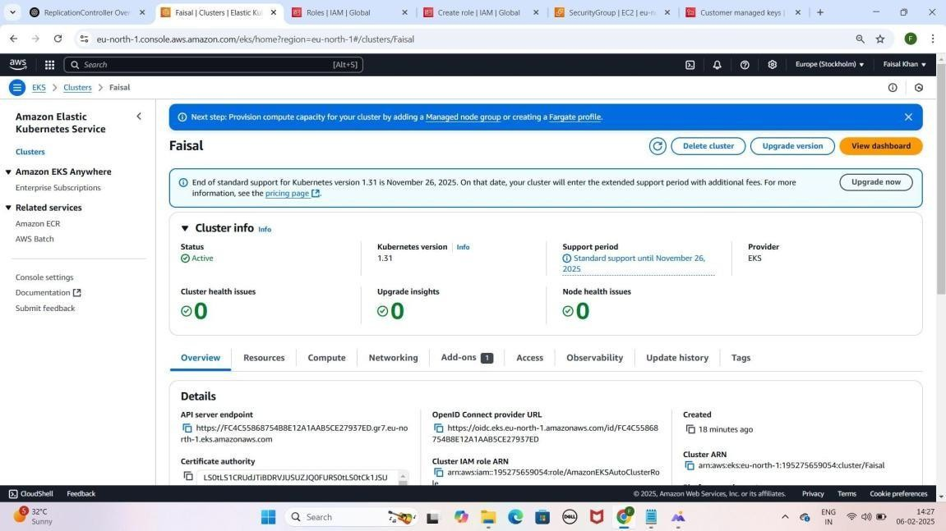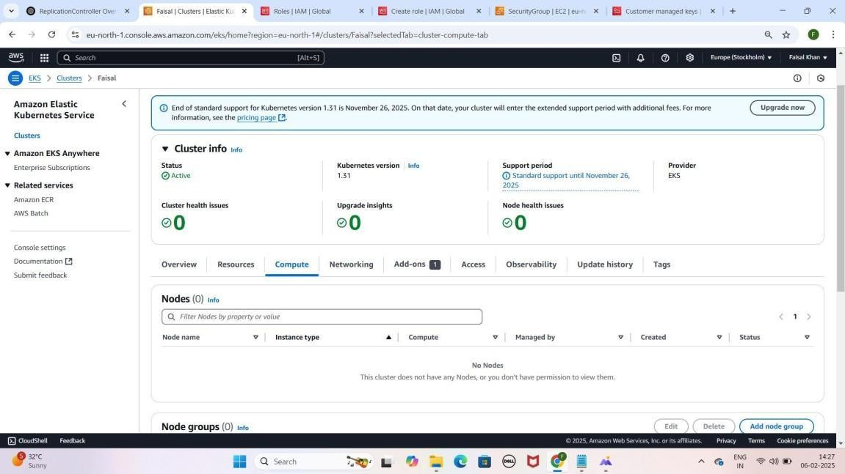YE KUCH ISTARHA LAGEGA

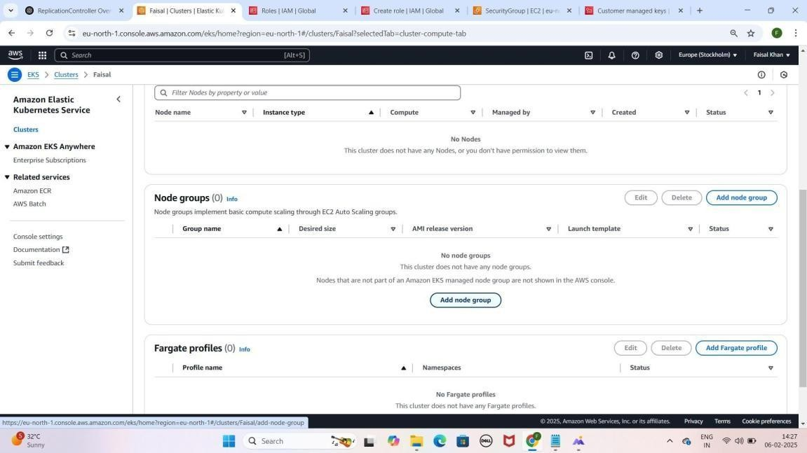

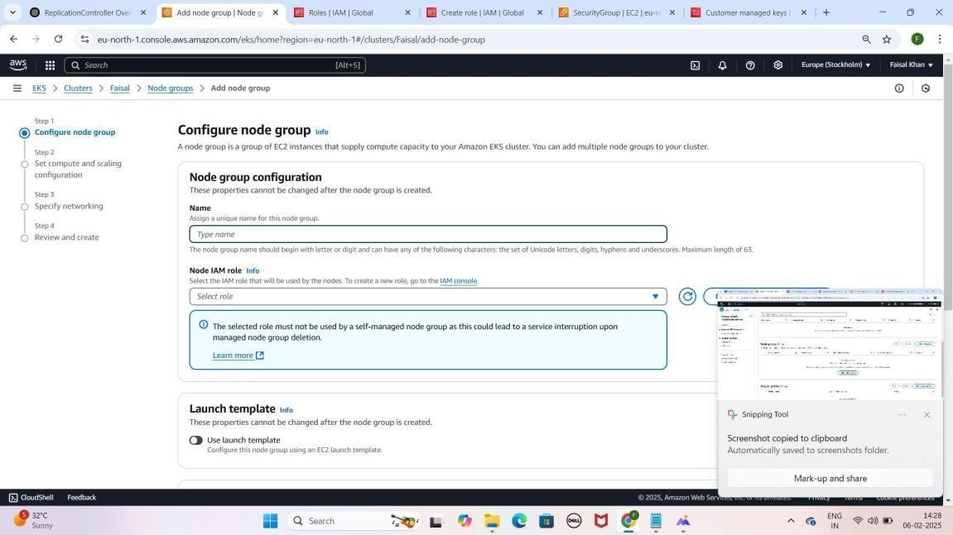

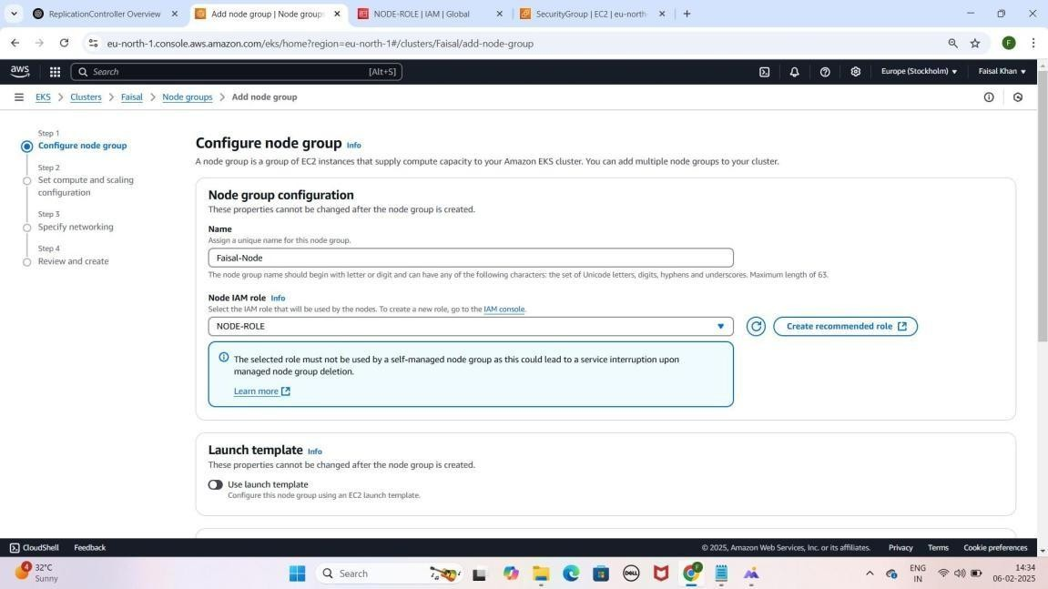

1. **IAM Role Create Karna**:**Node IAM Role** ke liye.
2. **Create Recommended Role pe click karo.**
3. **Use Case: EC2 select hoga.**
   * **AdministratorAccess**
   * **AmazonEC2ContainerRegistryReadOnly**
   * **AmazonEKS_CNI_Policy**
   * **AmazonEKSClusterPolicy**
   * **AmazonEKSLoadBalancingPolicy**
   * **AmazonEKSNetworkingPolicy**
   * **AmazonEKSWorkerNodePolicy**
   * **AmazonSSMManagedInstanceCore**
   * **AWSLoadBalancerControllerIAMPolicy**
   * **EC2InstanceConnect**
   * **ElasticLoadBalancingFullAccess**
4. **Role Name: NODE-ROLE**
5. **Create Role** pe **click** karo.
6. **EKS Console** wapas jao, **NODE-ROLE select** karo

YE KUCH ISTARHA LAGEGA

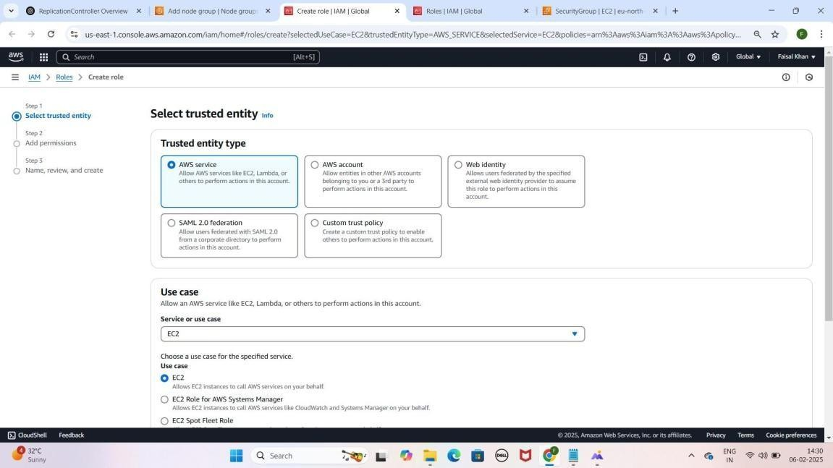

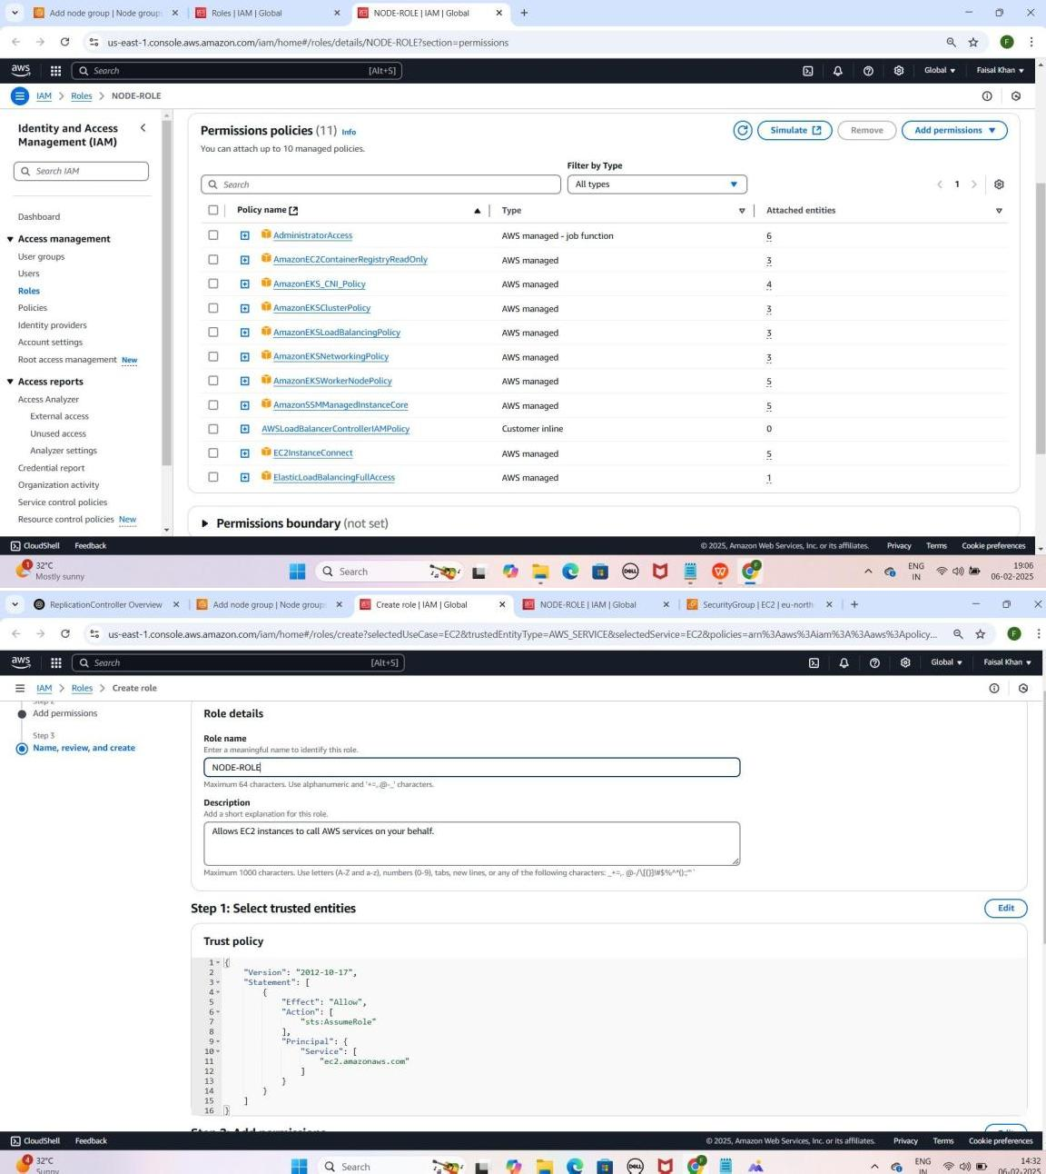



### Step 9: Compute & Scaling Configurations

1. **Instance Type**: t3.large select karo
2. **Disk Size**: 100 GiB
3. **Desired Size**: 1
4. **Min & Max Size**: 1
5. **Node Auto Repair** enable karo.

YE KUCH IS TARHA LAGEGA

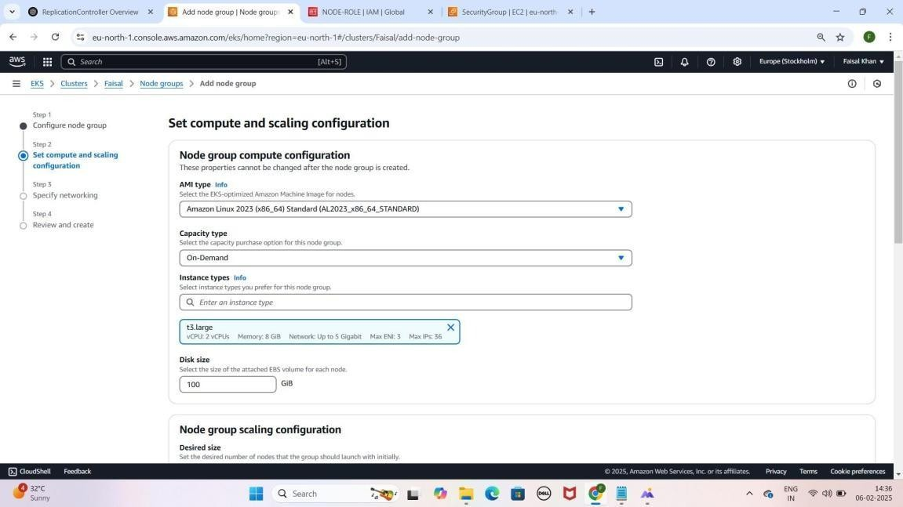

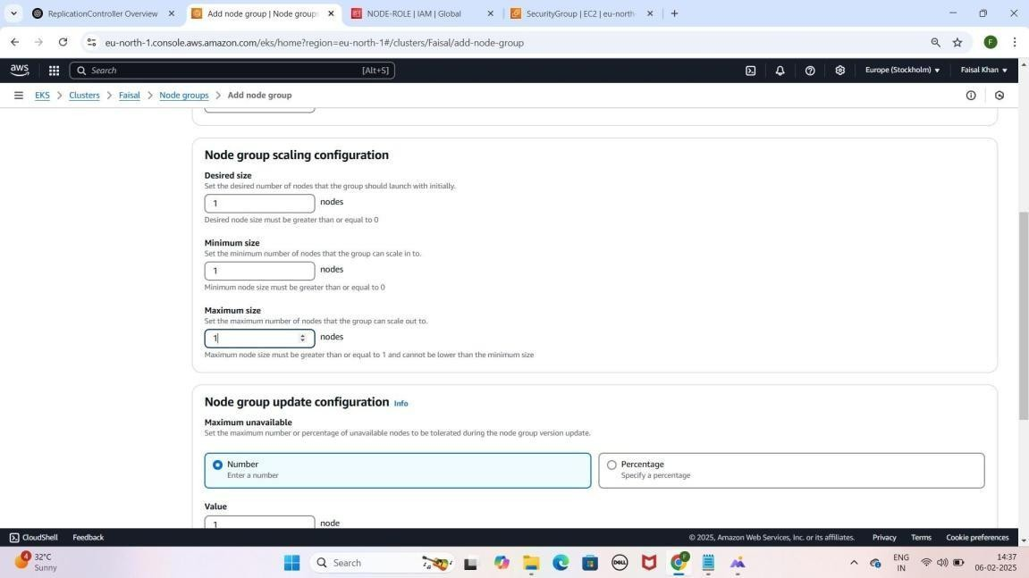

### Step 10: Specify Networking

1. **Configure Remote Access enable** karo.
2. **Key Pair select** karo.
3. **Security Group**: **ALL-TRAFFIC-ALLOW select** karo.
4. **Review & Create** karo, phir **Create Node Group** pe click karo.
5. **EC2 Console** jao, **Instances** section mein **Faisal-Node** instance rename karo --> (Aapka Name Likho)

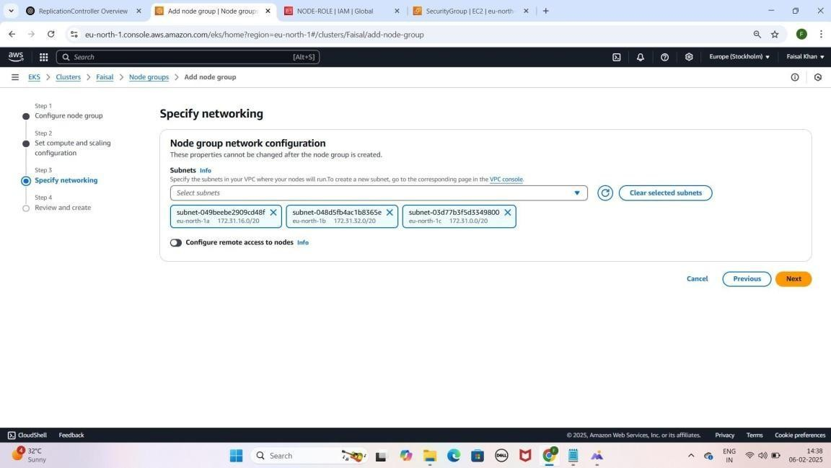YE KUCH ISTARHA LAGEGA

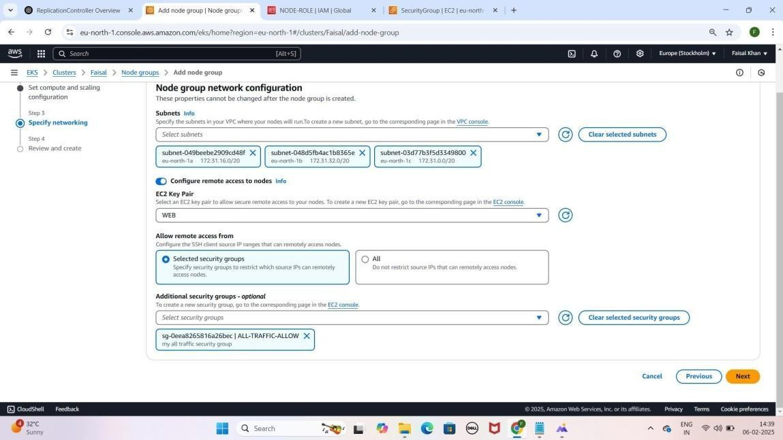

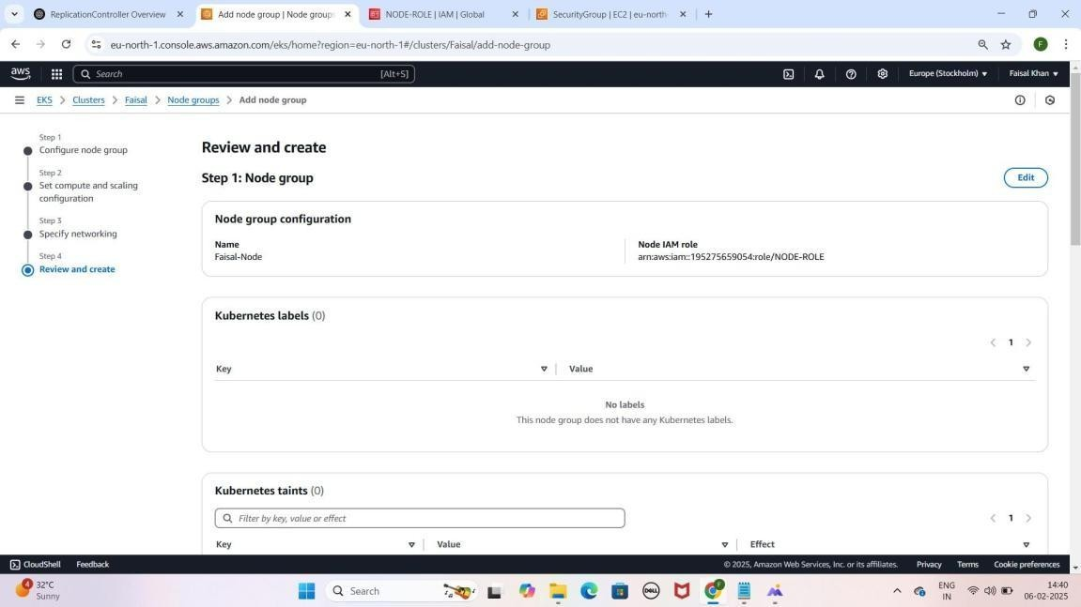

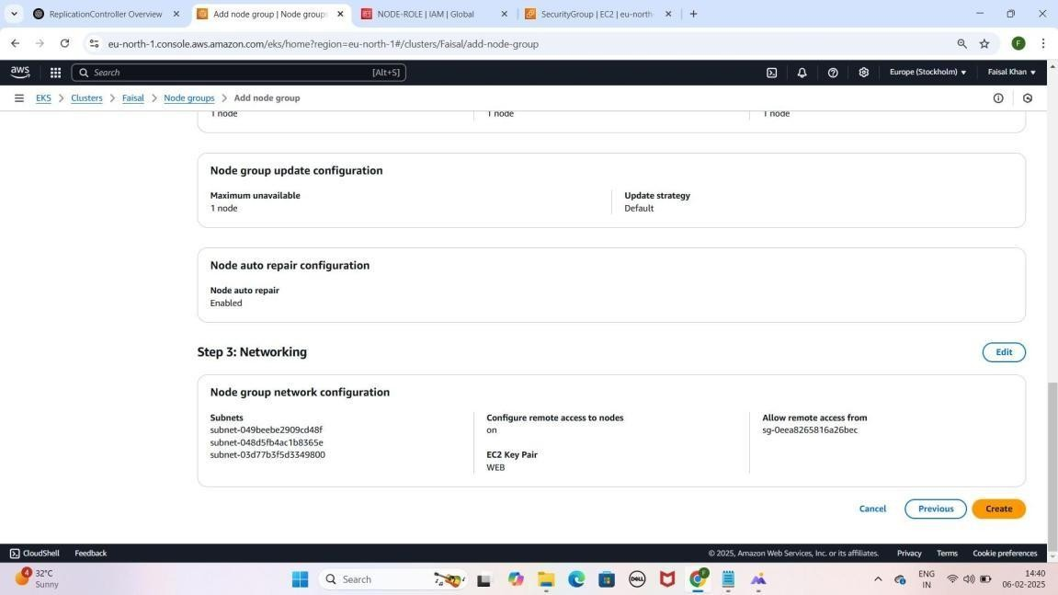

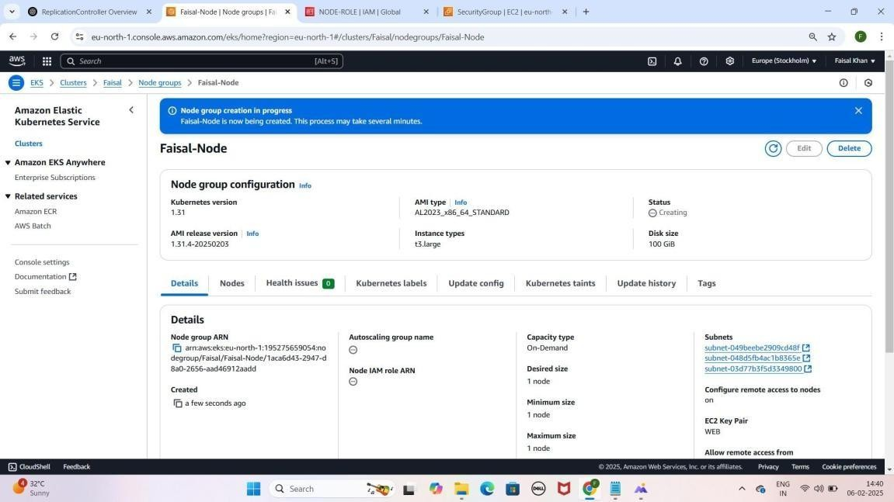

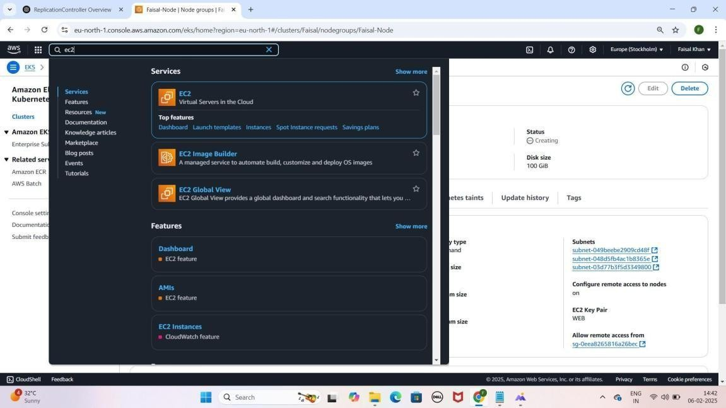

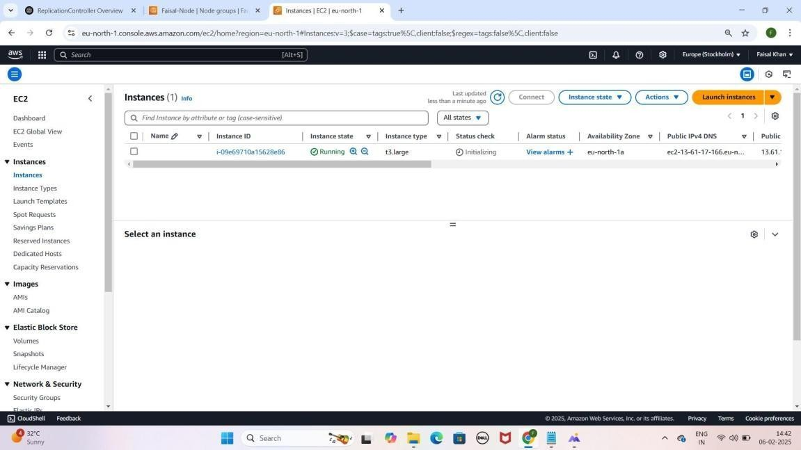

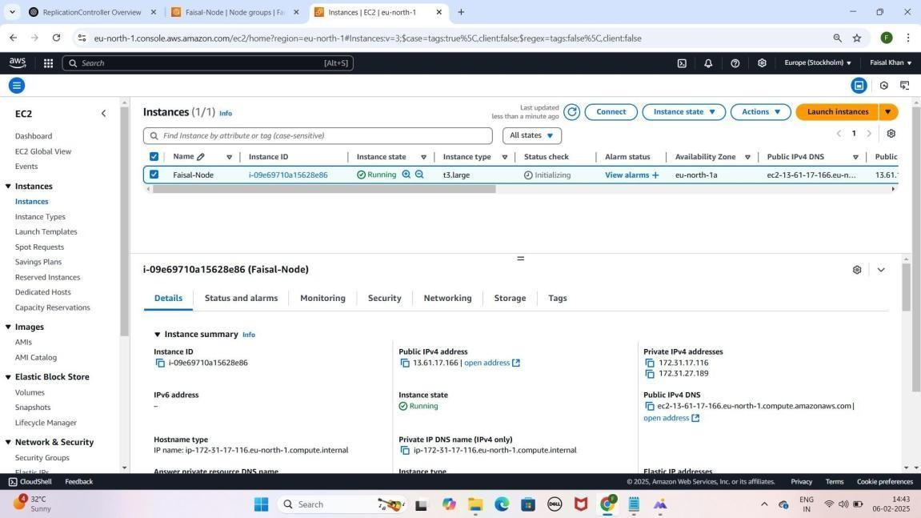

### Step 11: Cluster Security Group Update Karna

1. **EKS Console** pe jao, **cluster** select karo.
2. **Networking** tab mein **Cluster Security Group** open karo.
3. **Inbound Rules Edit Karo**:
   1. Default rule remove karo.
   2. **New Rule**:
      1. **Type**: All Traffic
      2. **Source**: Anywhere IPv4
4. **Save Rules** pe **click** karo.

YE KUCH ISTARHA LAGEGA

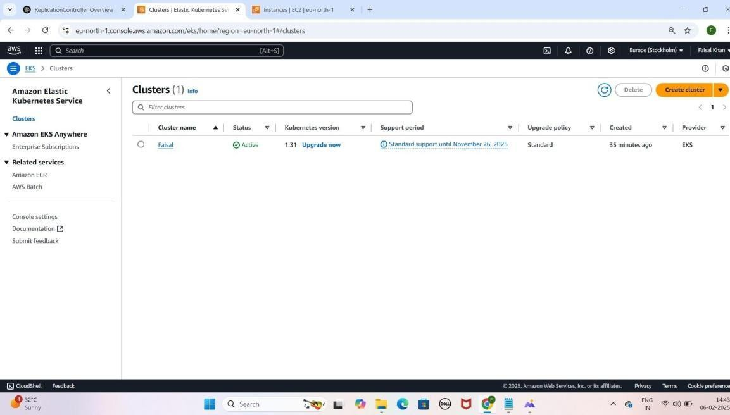

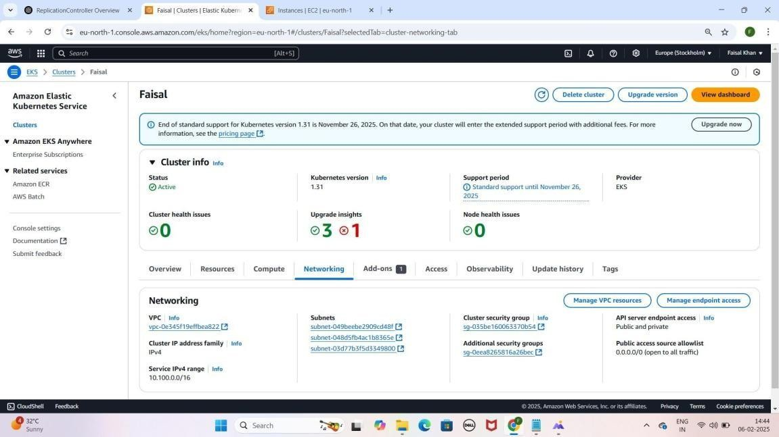

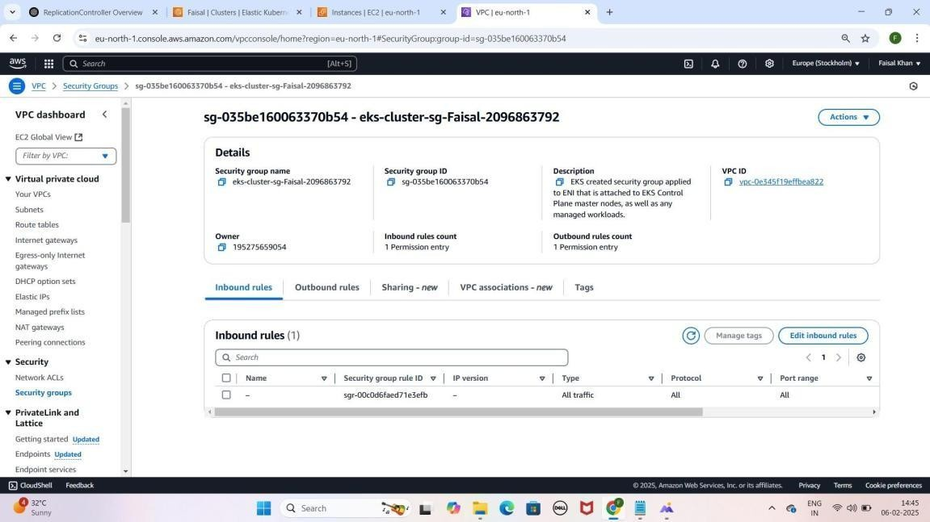

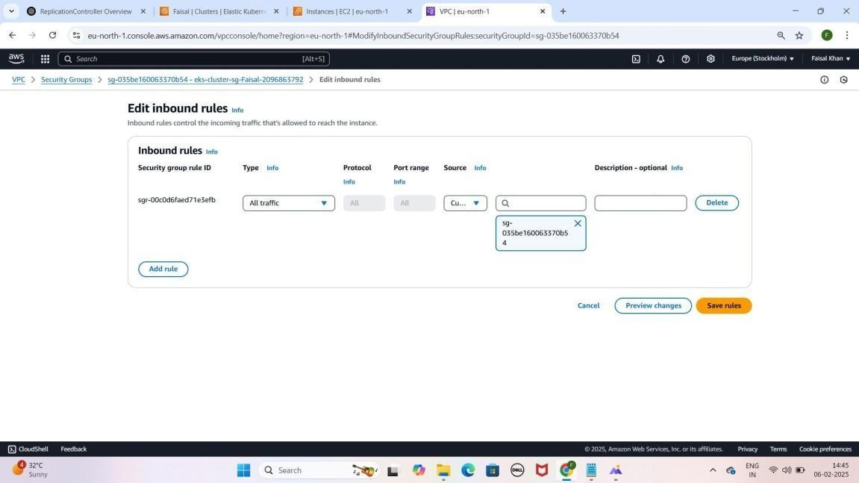

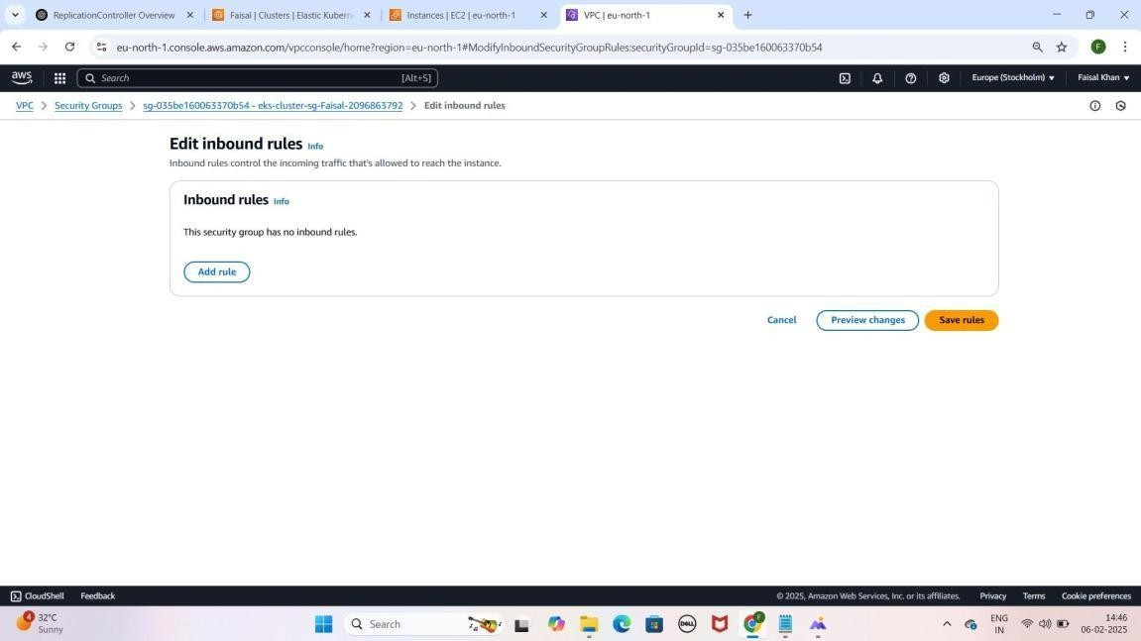



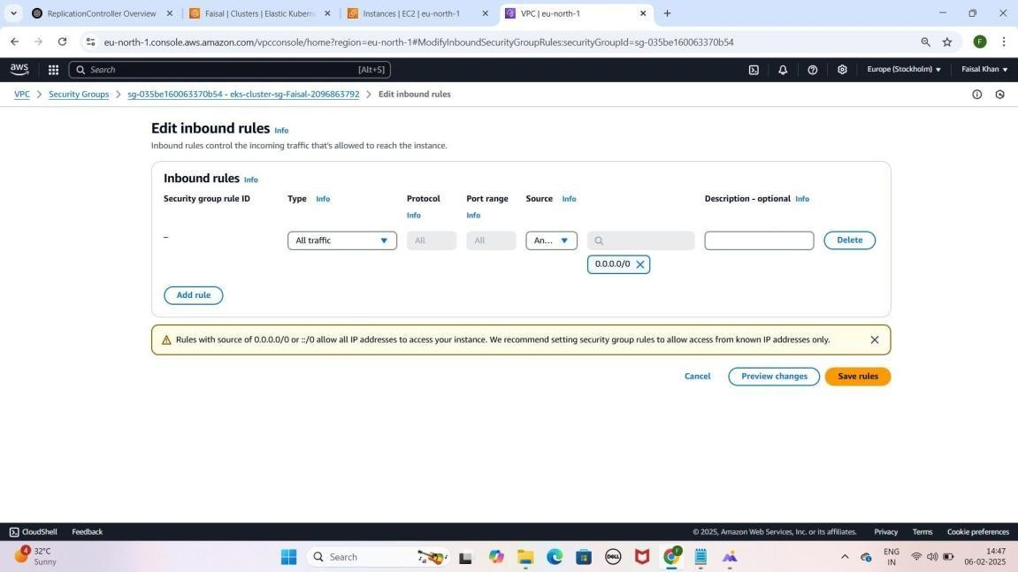

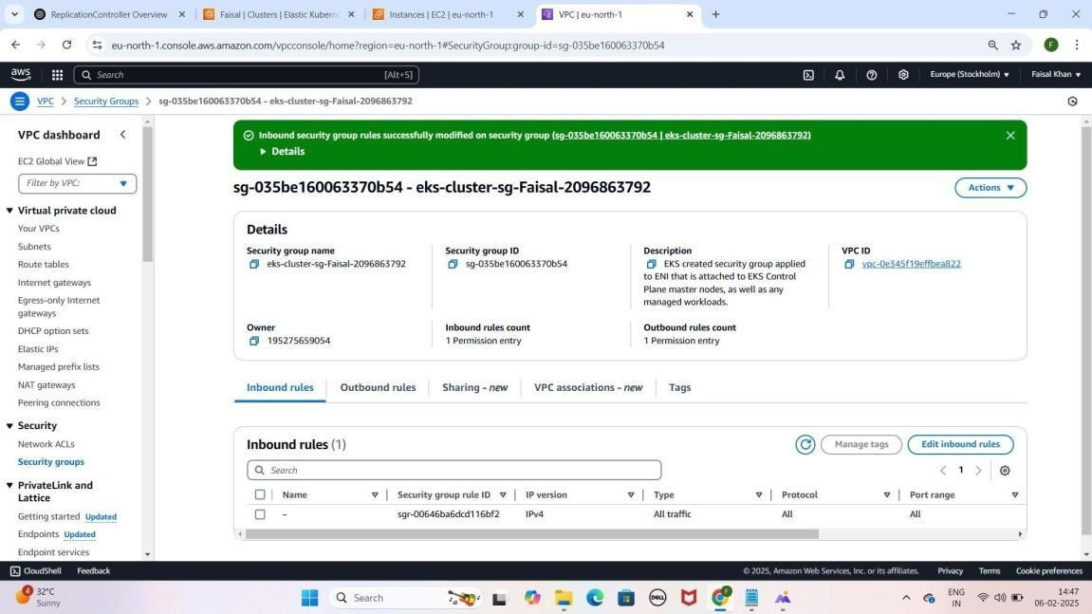

### Step 12: Node Instance ke Security Group Update Karna

1. **EC2 Console** pe jao.
2. **Instances** section mein apni **Node Instance (Faisal-Node)** select karo.
3. **Security Tab** pe jao aur **Outbound Rules** ka **Security Group** open karo.
4. **Edit Inbound Rules** karo
   1. **Default rule remove** karo.
   2. **New Rule Add Karo**:
      1. **Type**: All Traffic 2.

**Source**: Anywhere IPv4

1. **Save Rules** pe **click** karo.

YE KUCH ISTARHA LAGEGA

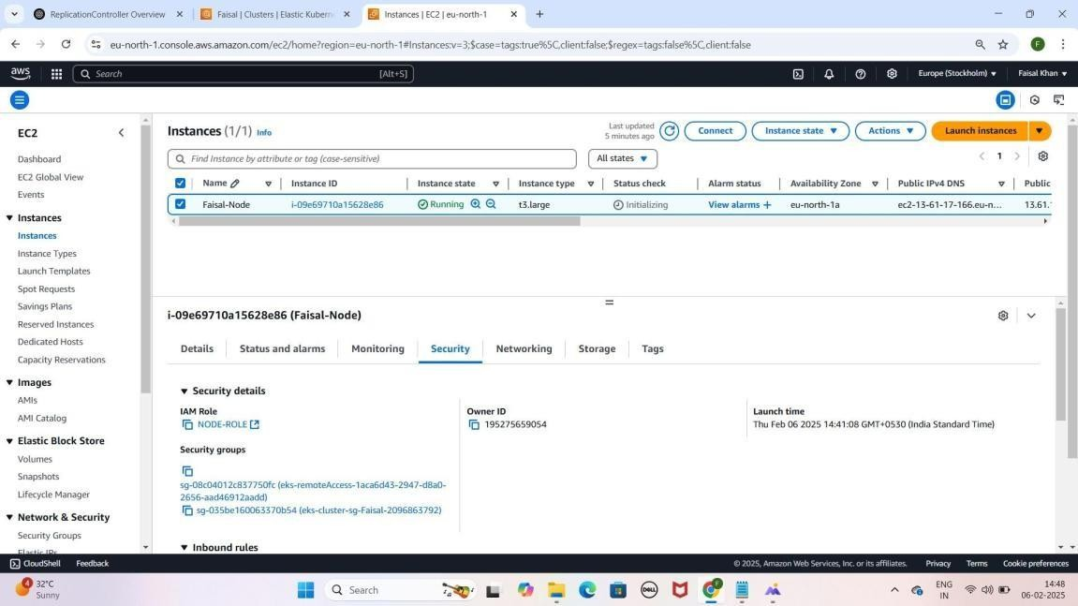

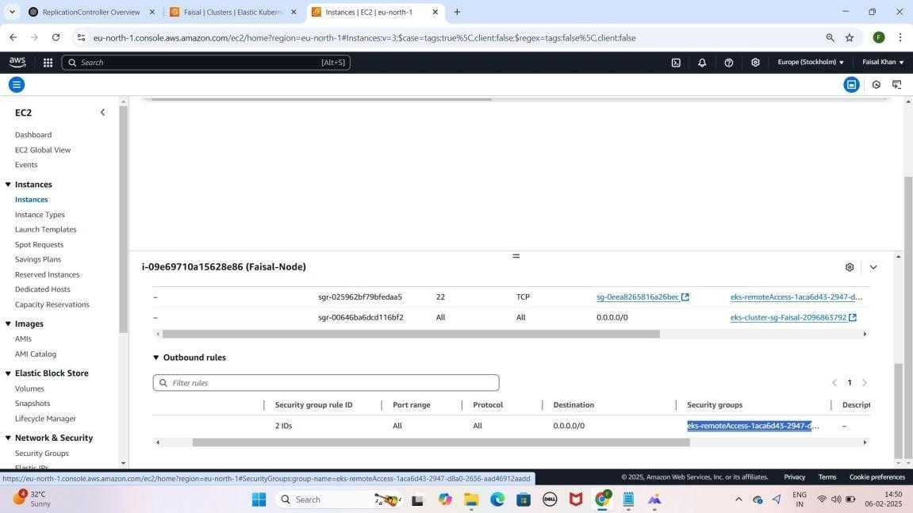

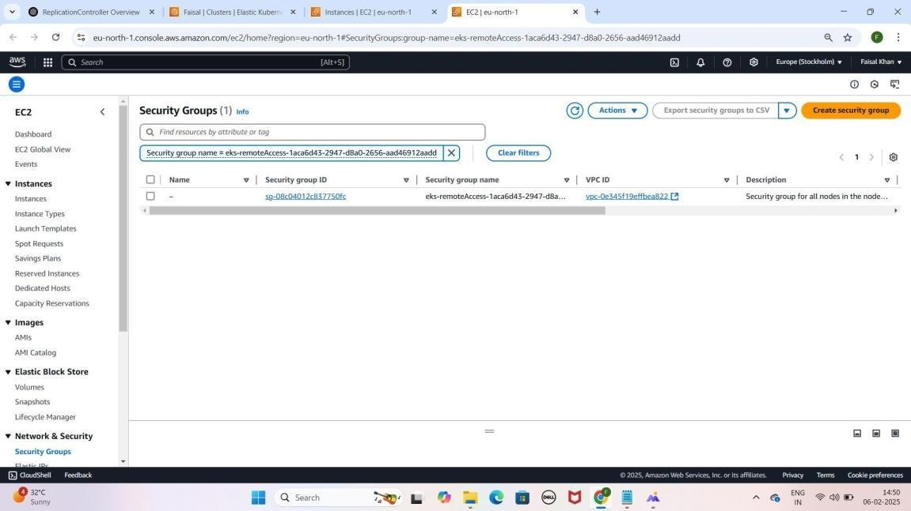



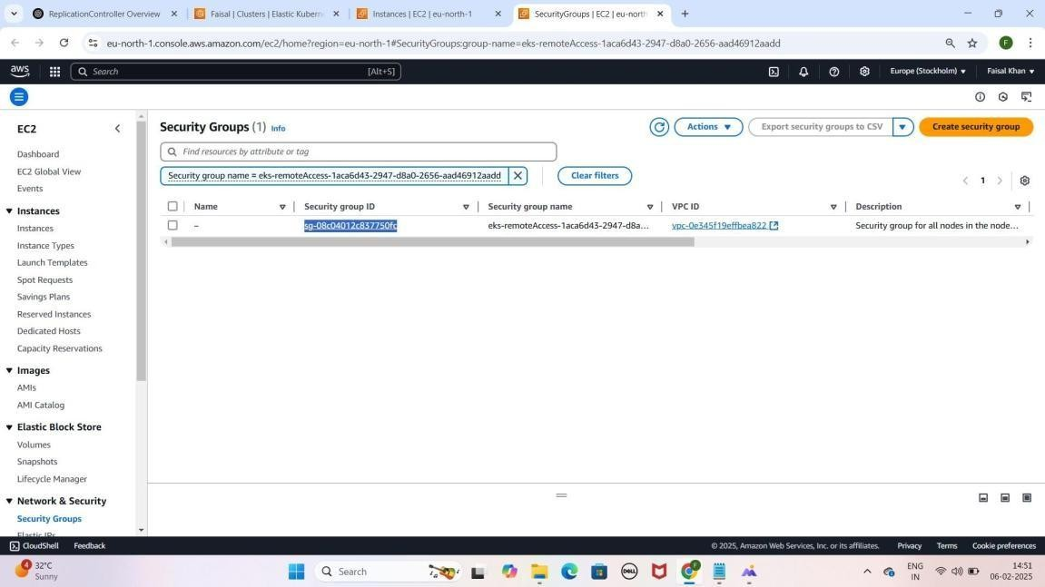

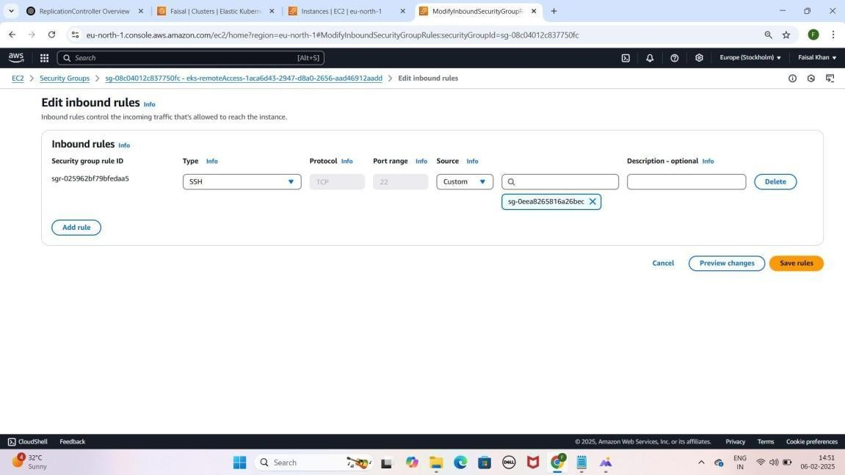

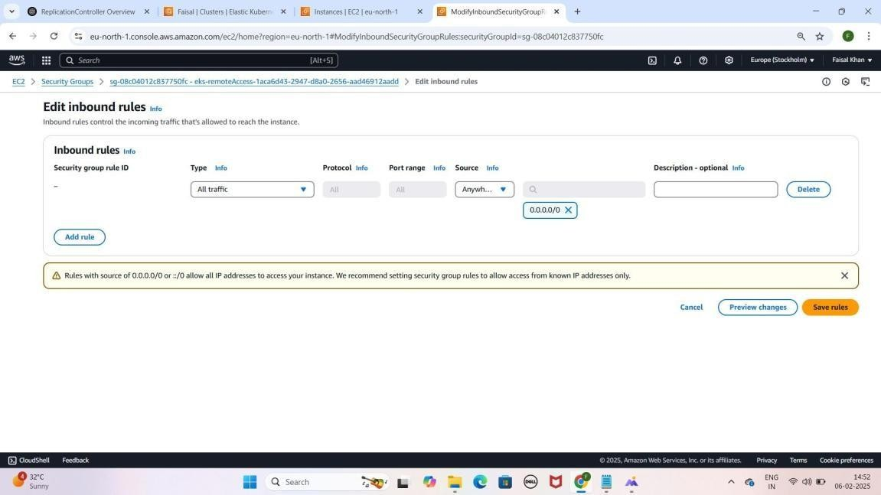

# Part 2: Required Tools Install Karna

1. **Chocolatey Install karo**
2. **Kubectl Install karo**
3. **WSL Install karo** (Future me iski zaroorat hogi)
4. **Docker Install karo WSL me** (Future me iski zaroorat hogi)
5. **NPM Install karo WSL me** (Future me iski zaroorat hogi)
6. **Git Install karo** (Future me iski zaroorat hogi)
7. **AWS CLI**

### Step 1: Windows PowerShell ko administrator Mode me Open karein or Chocolatey install karein

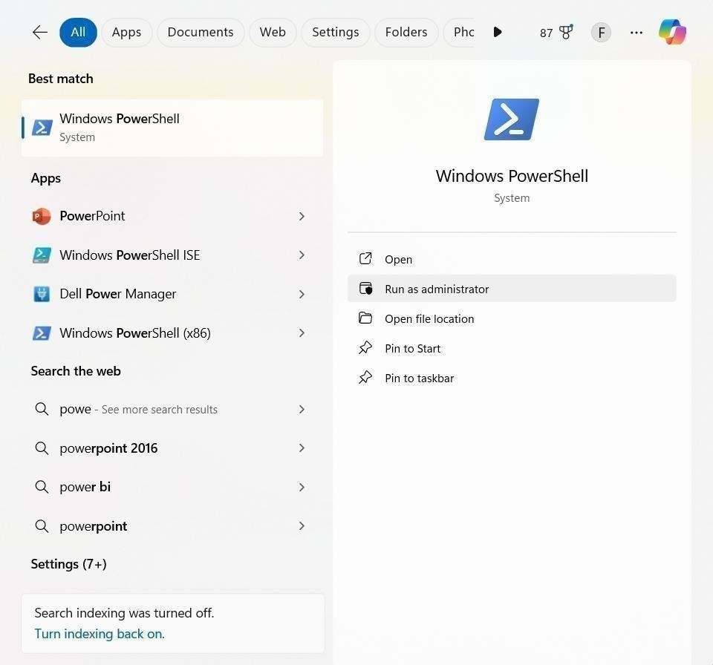YE KUCH ISTARHA LAGEGA

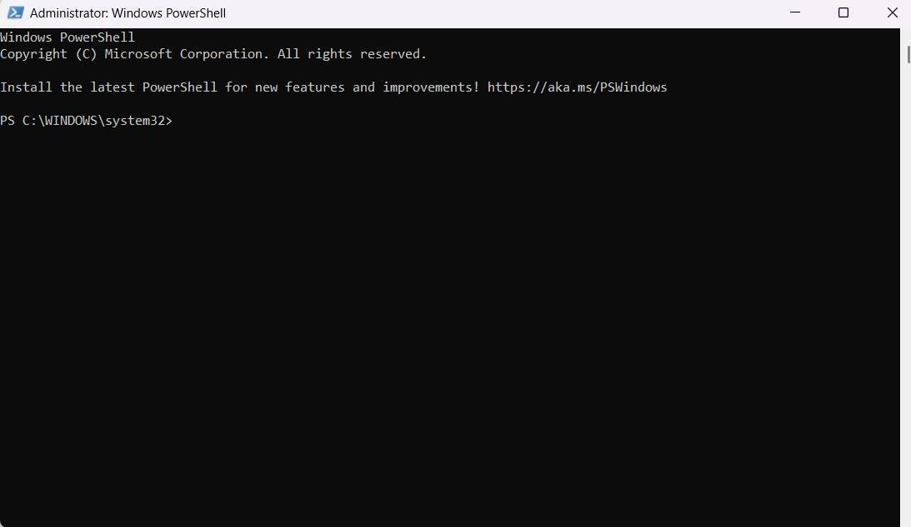

Chocolatey

Chocolatey ek package manager hai jo Windows pe software install karna easy banata hai.

1. **Chocolatey install karne ke liye ye command poora copy karo**

Set-ExecutionPolicy Bypass -Scope Process -Force; [System.Net.ServicePointManager]::SecurityProtocol = [System.Net.SecurityProtocolType]::Tls12; iex ((New-Object System.Net.WebClient).DownloadString('https://community.chocolatey.org/install.ps1'))

Set-ExecutionPolicy Bypass -Scope Process -Force; [System.Net.ServicePointManager]::SecurityProtocol = [System.Net.SecurityProtocolType]::Tls12; iex ((New-Object System.Net.WebClient).DownloadString('https://community.chocolatey.org/install.ps1'))

YE KUCH ISTARHA LAGEGA

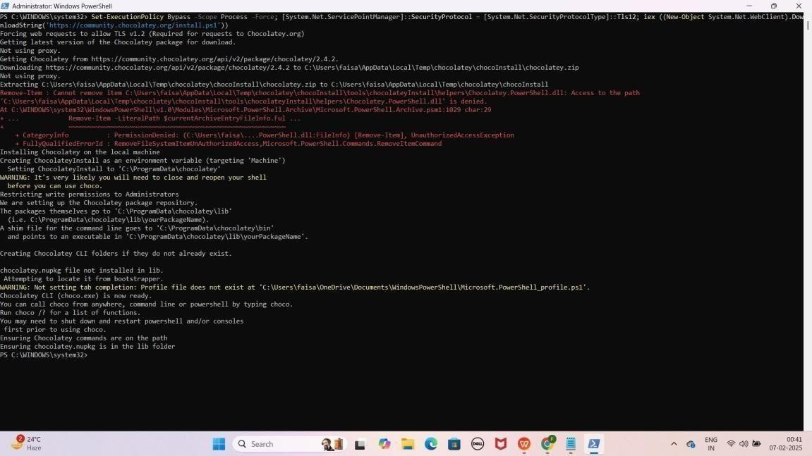

1. **Chocolatey update karne ke liye ye command run kariye**

choco upgrade chocolatey -y

YE KUCH ISTARHA LAGEGA

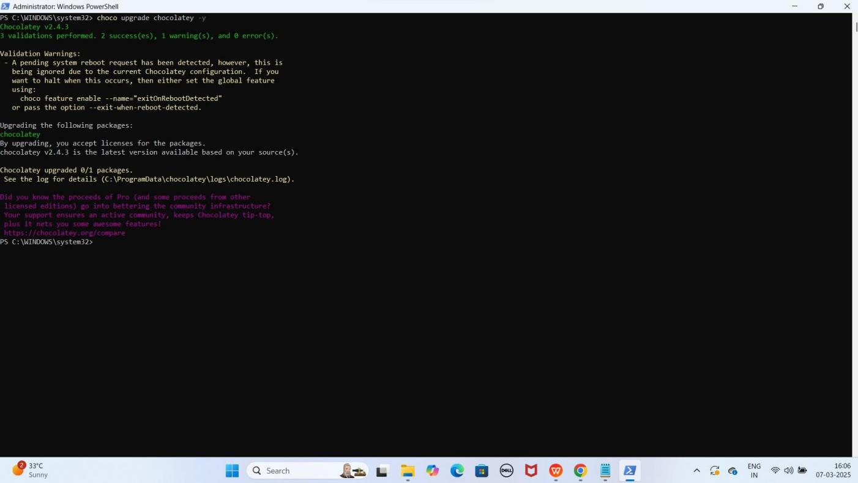

1. **Check karo Chocolatey install hua ya nahi ye command run kariye**

choco

YE KUCH ISTARHA LAGEGA

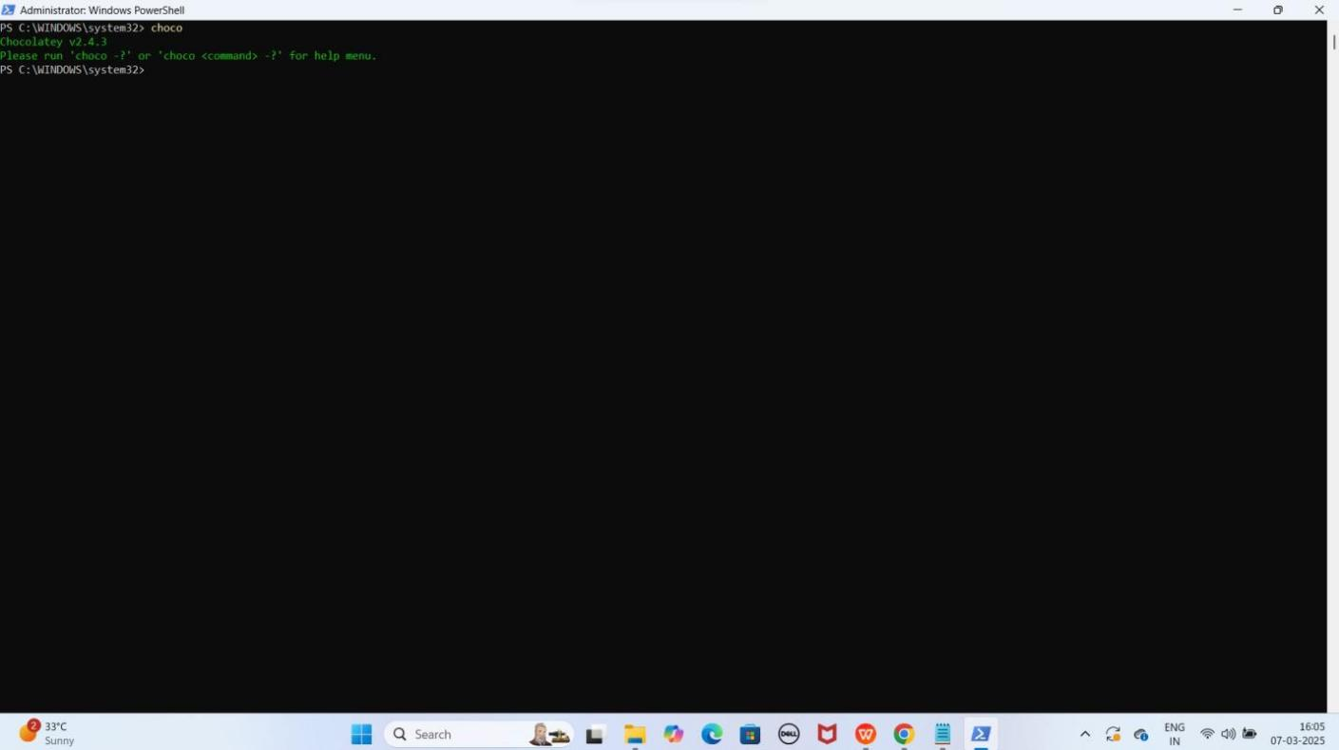

### Step 2: Kubectl Install Karna

Kubectl Kubernetes clusters ko manage karne ke liye use hota hai.

1. **Install karne ke liye ye command run kariye**

choco install kubernetes-cli --force -y

YE KUCH ISTARHA LAGEGA

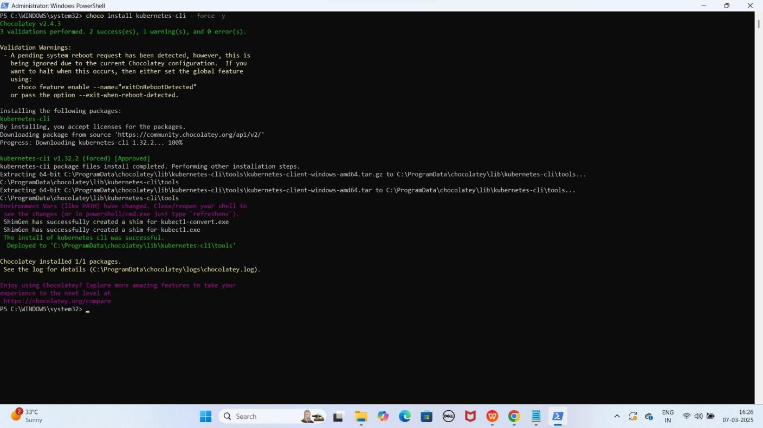

1. **Check karne ke liye ye command run kariye**

kubectl version --client

YE KUCH ISTARHA LAGEGA

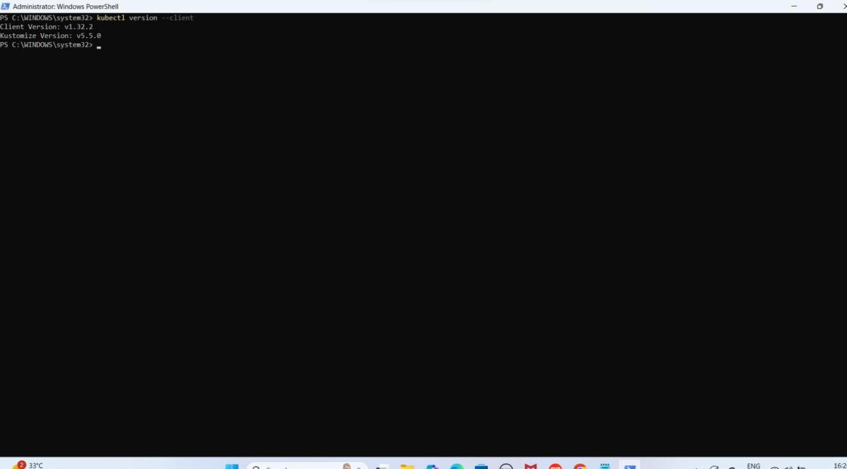

### Step 3: WSL Install Karna (Future purpose ke liye)

WSL (Windows Subsystem for Linux) Linux environment provide karta hai.

1. **Install karne ke liye ye command run kariye**

winget install --id Microsoft.WSL -e --source winget

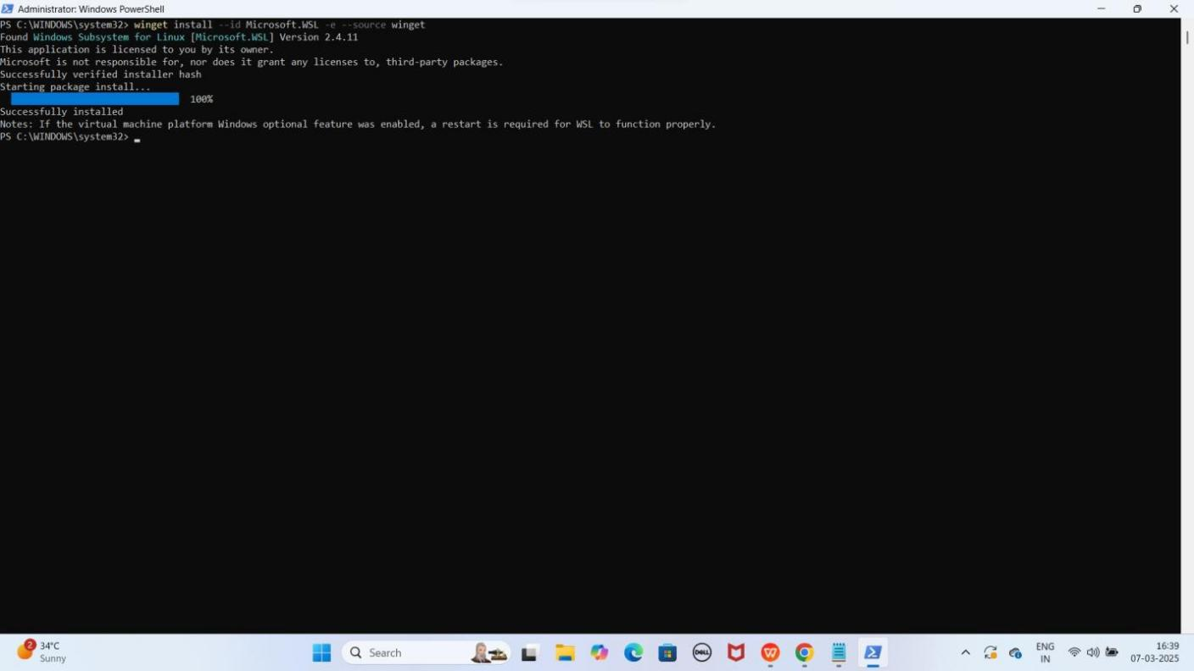YE KUCH ISTARHA LAGEGA

1. **Check karne ke liye ye command run kariye**

wsl --version

YE KUCH ISTARHA LAGEGA

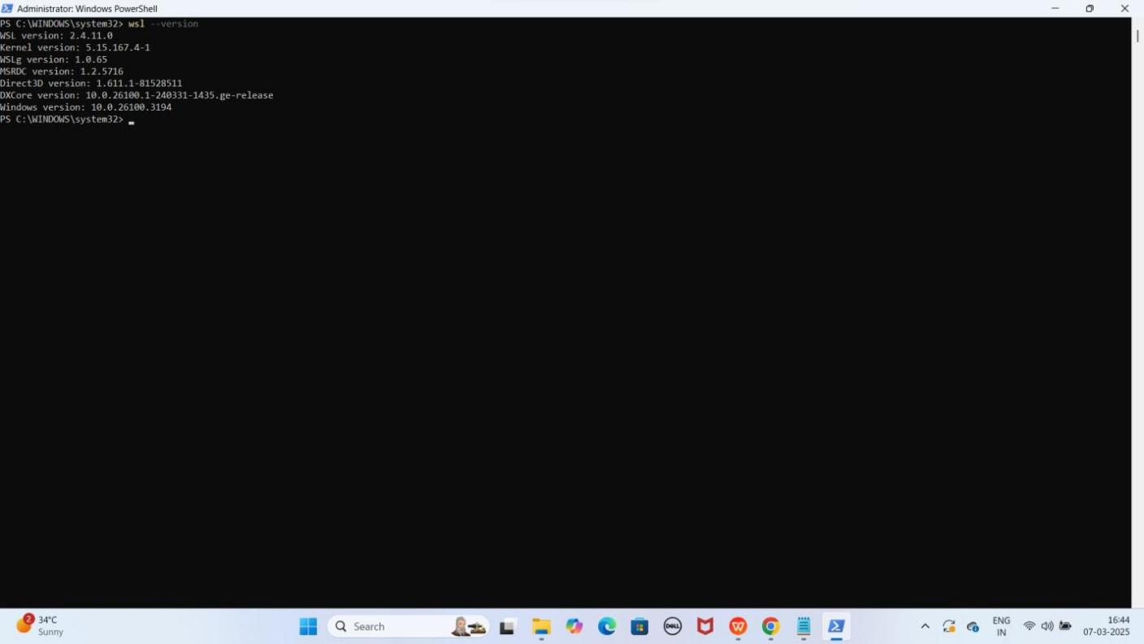

1. **Required features enable karne ke liye ye commands run kariye**

Start-Process -FilePath "dism.exe" -ArgumentList "/online /enable-feature

/featurename:Microsoft-Windows-Subsystem-Linux /all /norestart" -Verb RunAs

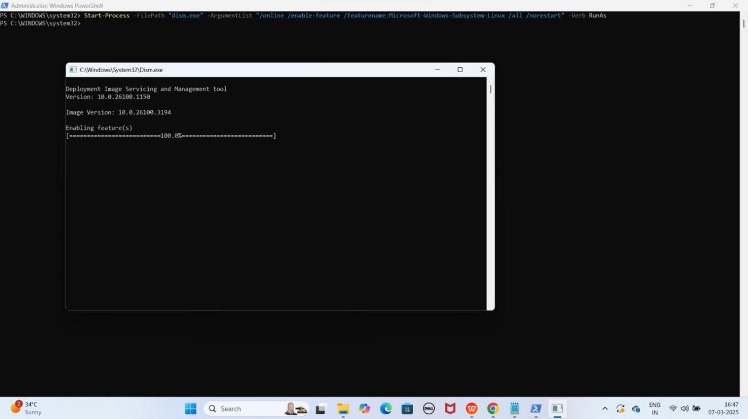YE KUCH ISTARHA LAGEGA

Start-Process -FilePath "dism.exe" -ArgumentList "/online /enable-feature

/featurename:VirtualMachinePlatform /all /norestart" -Verb RunAs

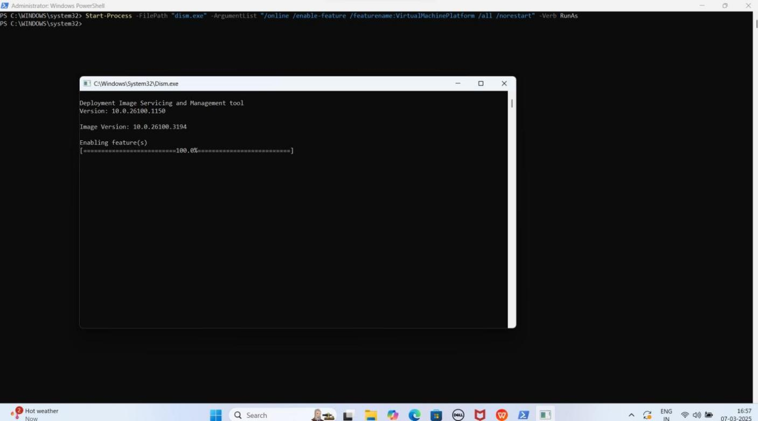YE KUCH ISTARHA LAGEGA

Start-Process -FilePath "bcdedit.exe" -ArgumentList "/set hypervisorlaunchtype auto" -Verb RunAs

Start-Process -FilePath "bcdedit.exe" -ArgumentList "/enum" -NoNewWindow -PassThru | Out-String | Select-String -Pattern "hypervisorlaunchtype"

YE KUCH ISTARHA LAGEGA

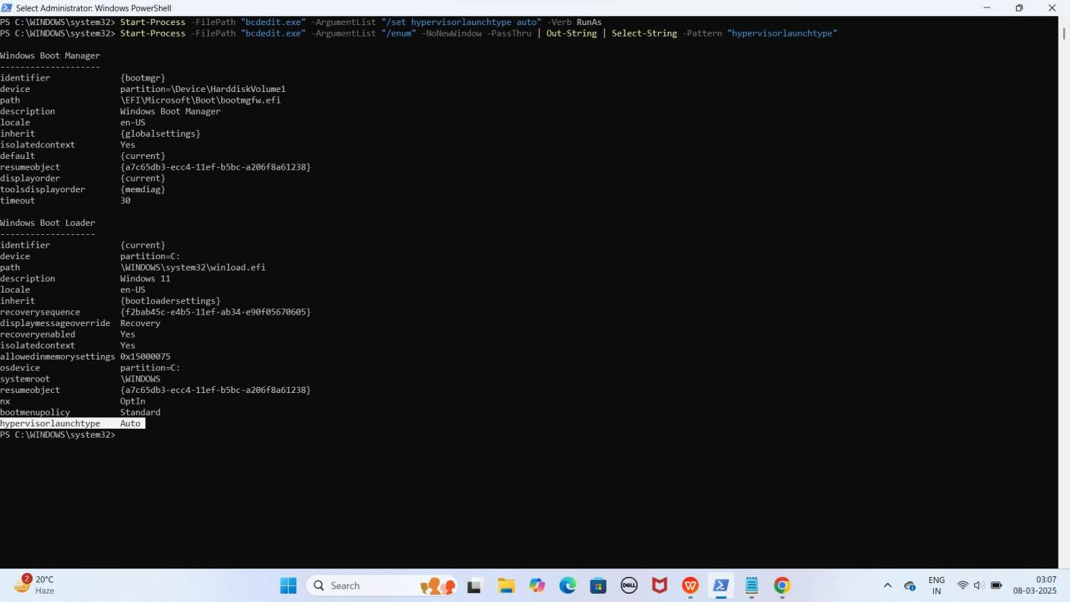

NOTE: Agar aapko hypervisorlaunchtype Auto show karrha hai to System Restart kariye System Restart hone ke baad phir Powershell ko Run as Administrator se open kariye or HyperVisor Enable howa check karne ke liye ye command run kariye

Get-ComputerInfo | Select-Object HyperV*

YE KUCH ISTARHA LAGEGA

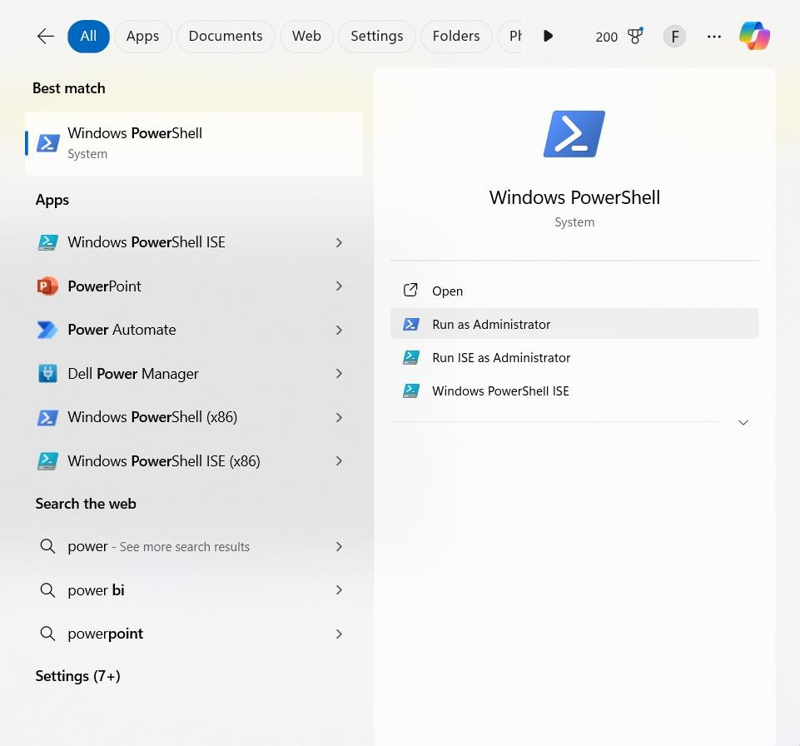

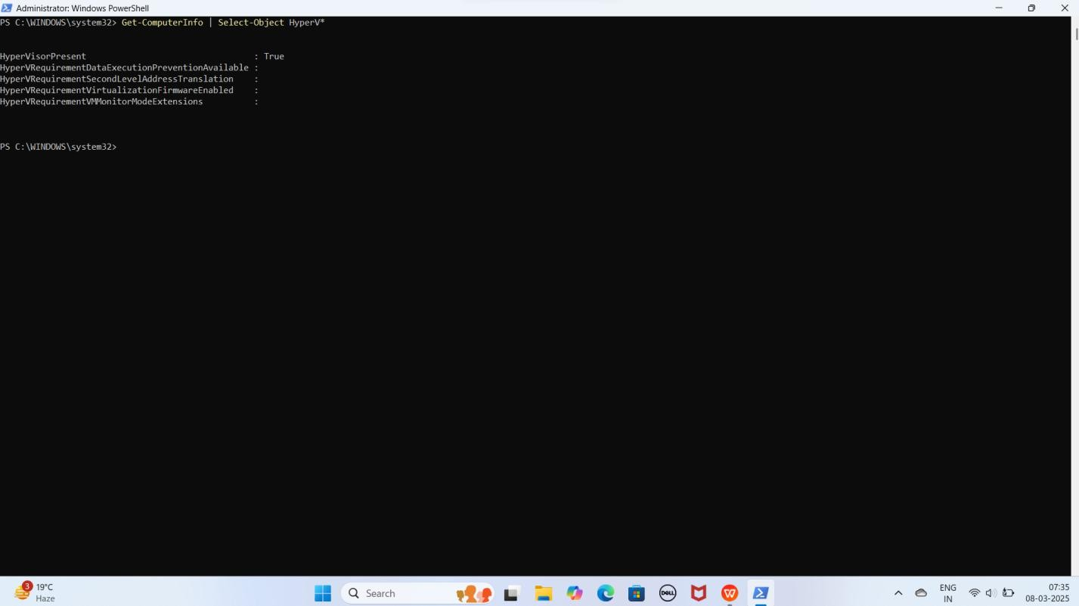

NOTE: Agar aapko HyperVisorPresent : True show kar raha iska matlab aapka Hypervisor Successfully Enable hogaya hai

1. **WSL version 2 set karne ke liye ye command run kariye**

wsl --set-default-version 2

YE KUCH ISTARHA LAGEGA

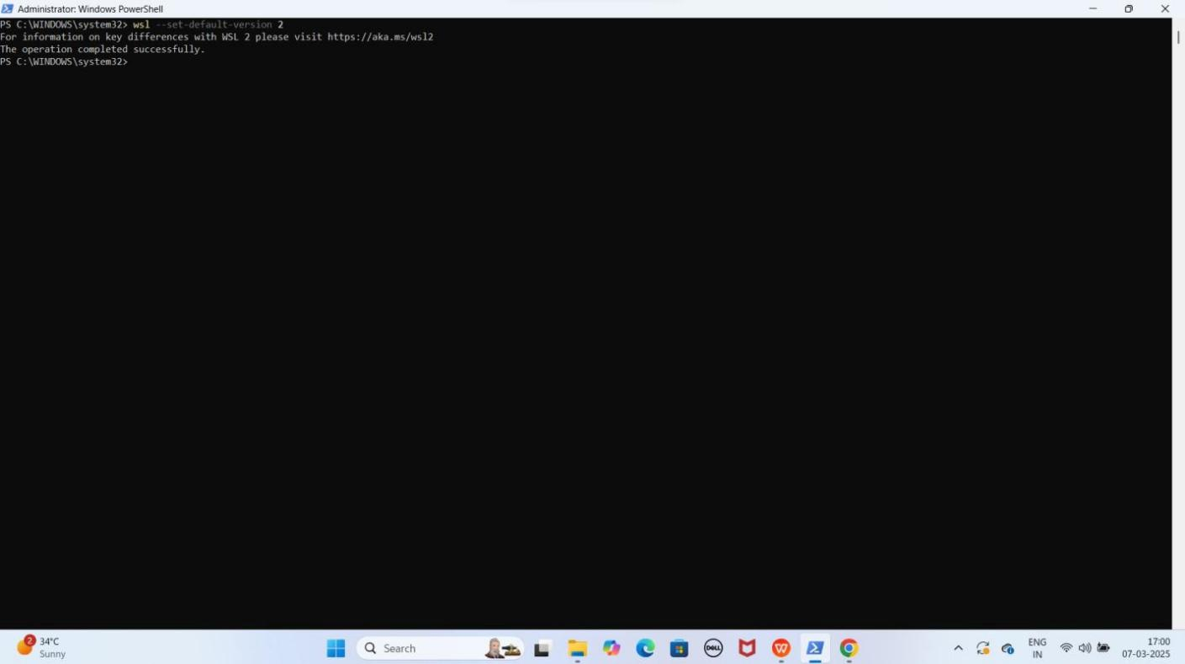

1. **Manually WSL Service Enable Karo**
   * **Win + R** dabao, **services.msc** likho aur **Enter** karo.
   * **"WSL service"** service dhundo.
   * Agar **Disabled** hai, to **Right-click → Properties → Startup type: Automatic(Delayed Start) → OK → Start** karo.

YE KUCH ISTARHA LAGEGA

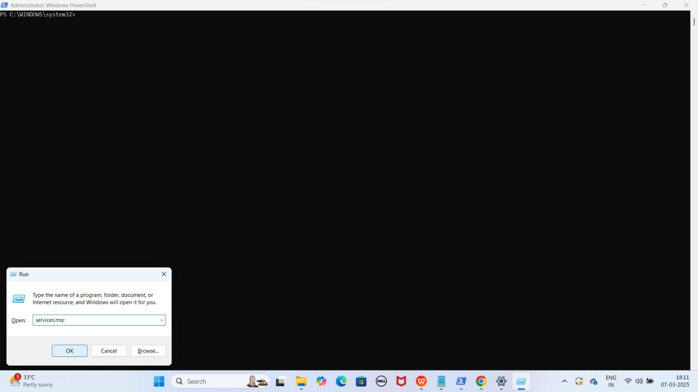

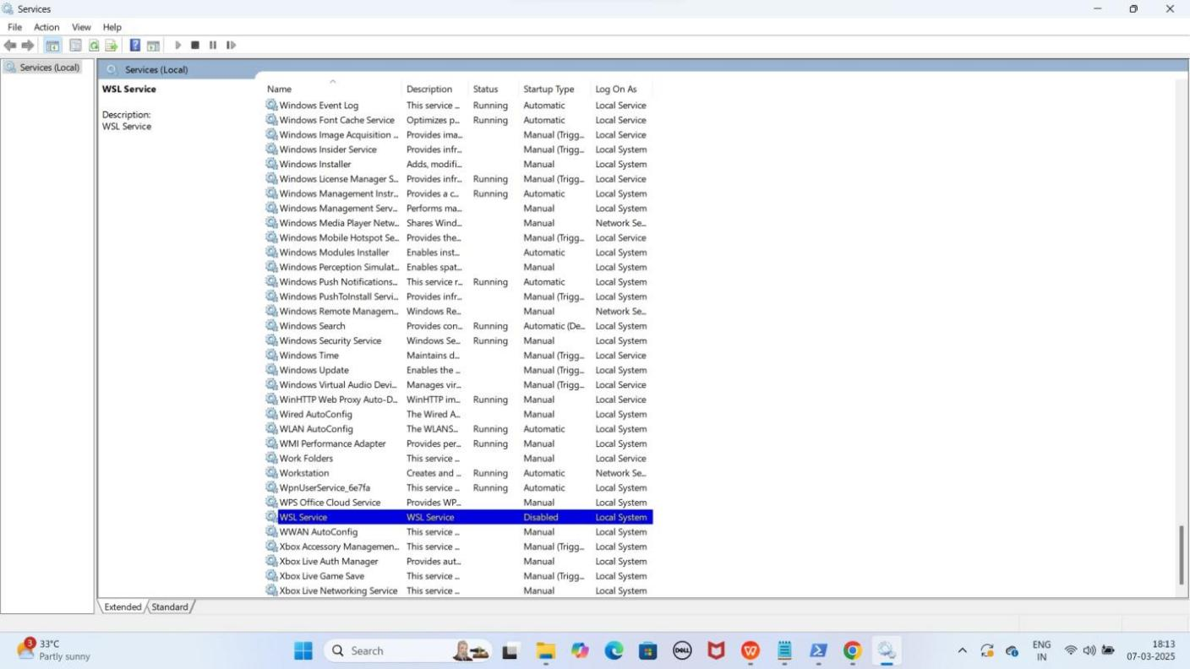

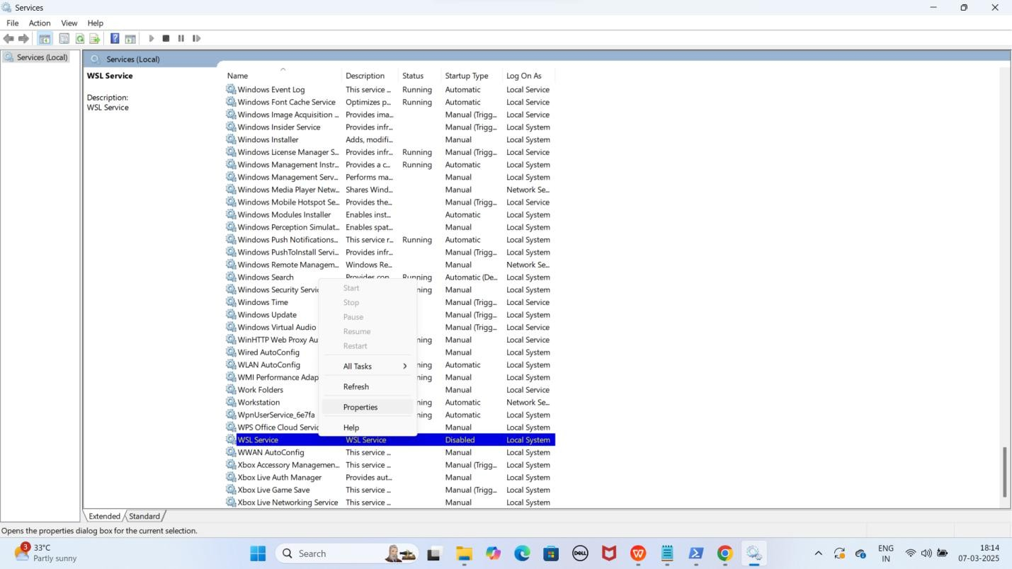

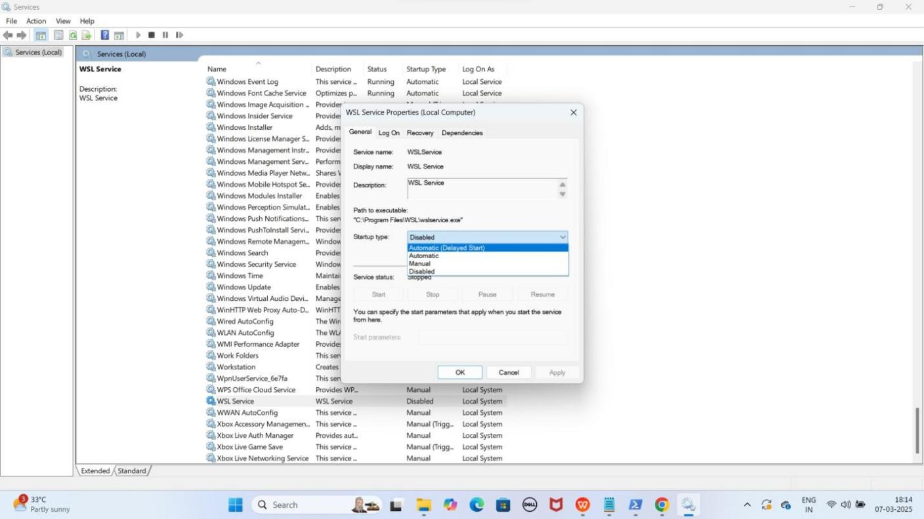

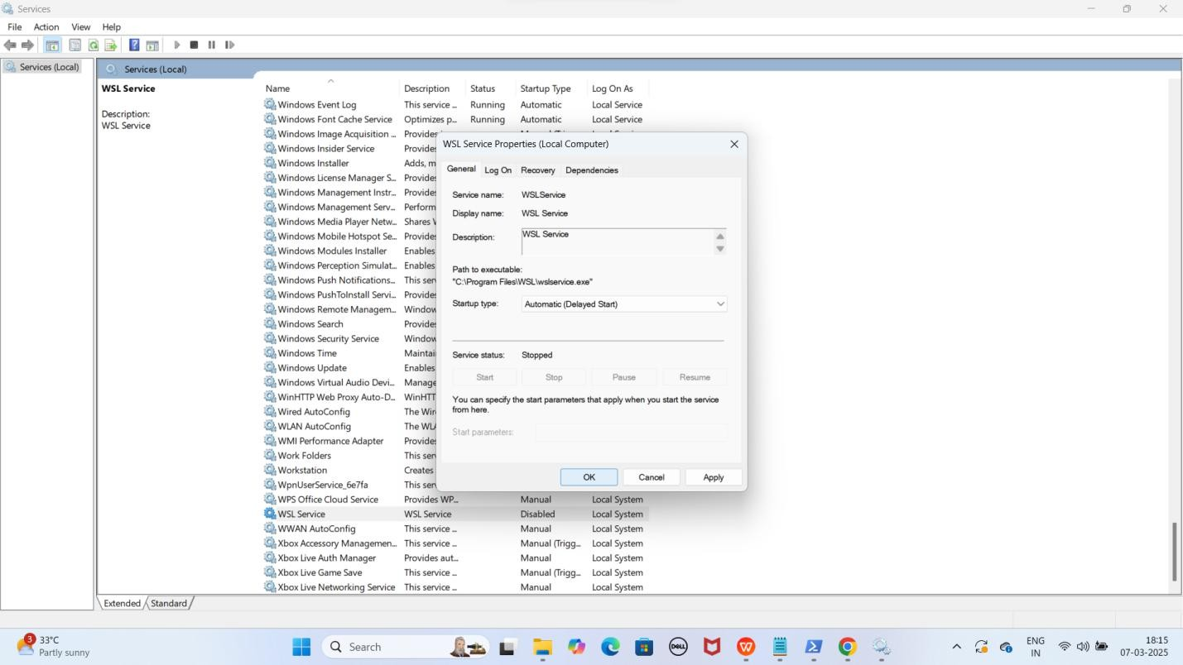

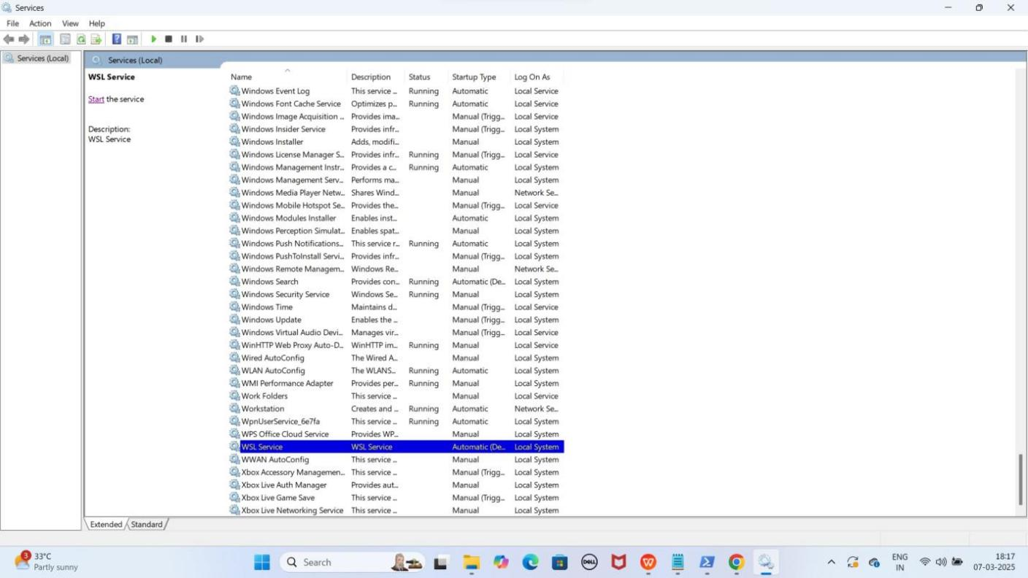

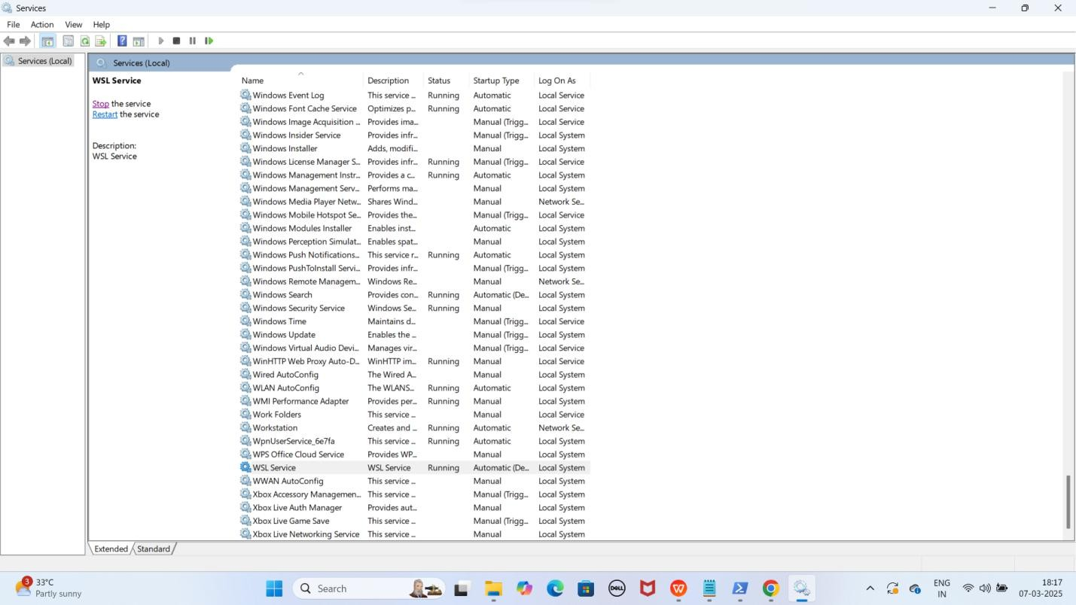

NOTE: Ab aapka WSL Service Enable and Start hogaya hai.

### Step 4: Ubuntu Install Kariye Ye WSL Ki Requirement Hai

Ubuntu WSL ke andar ek Linux distribution hai.

1. **Install karne ke liye ye command run kariye**

wsl --install -d Ubuntu-24.04

YE KUCH ISTARHA LAGEGA

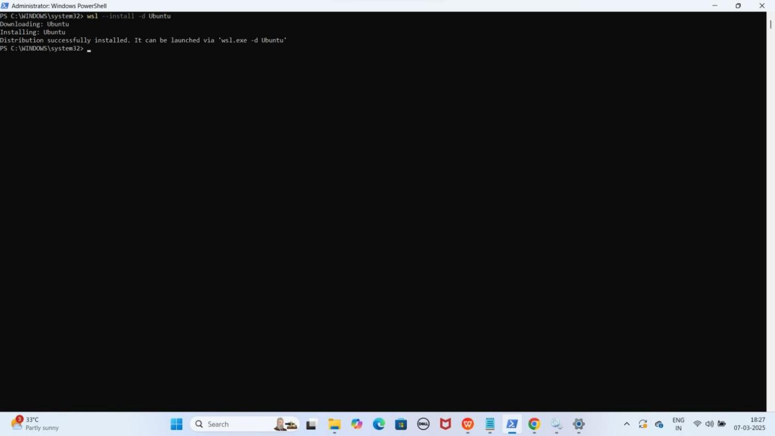

1. **Ubuntu manually launch karne ke lieye ye command run kariye**

wsl -d Ubuntu-24.04

Username aur password set karo

* 1. Username: **faisal** --> (Aapka Name Likho)
  2. Password: **faisalkhan35** --> (Aapke Name Se Password Set Karo)

YE KUCH ISTARHA LAGEGA

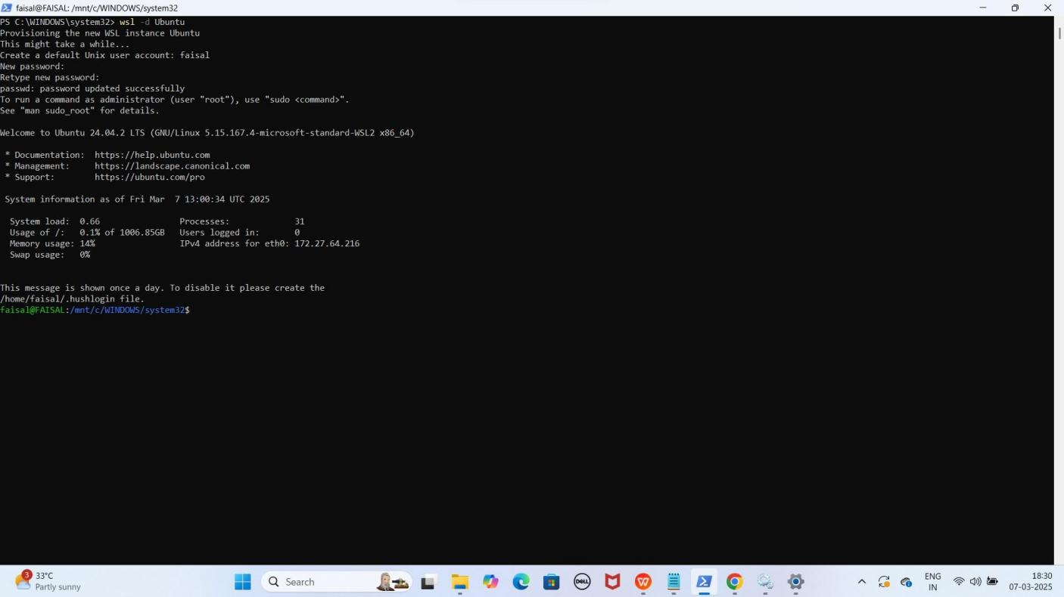

NOTE: Aapko password set karte waqt nahi dikhega. Or jaise hi WSL install hoga, aap by default WSL me enter ho jaoge. Lekin aapko exit hokar WSL Version 2 par Enable hai ya nahi check karne hoga

1. **Check karne ke liye ye command run kariye**

wsl -l -v

YE KUCH ISTARHA LAGEGA

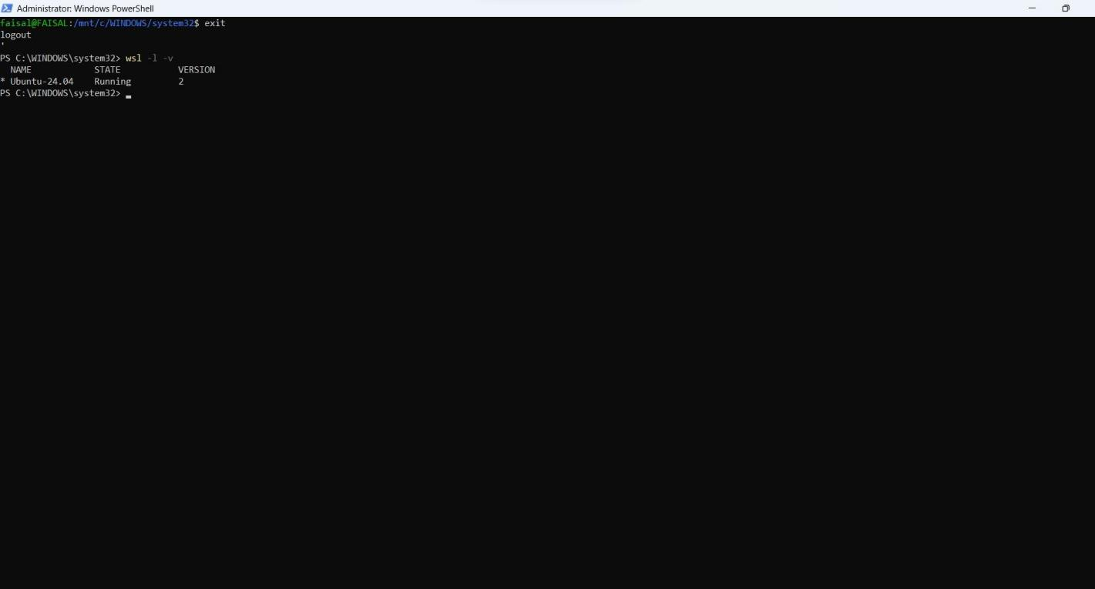

NOTE: Agar aapko STATE Running and VERSION 2 show horaha matlab aapka WSL version 2 par Enable hai and run ho raha hai

### Step 5: Docker install Karna WSL ke andar (Future purpose ke liye)

**Docker** ek **open-source platform** hai jo **applications** ko **containers** mein **package**

karne, distribute karne, aur run karne ki facility provide karta hai.

1. **Docker install karne ke liye wsl type karein**

wsl

YE KUCH ISTARHA LAGEGA

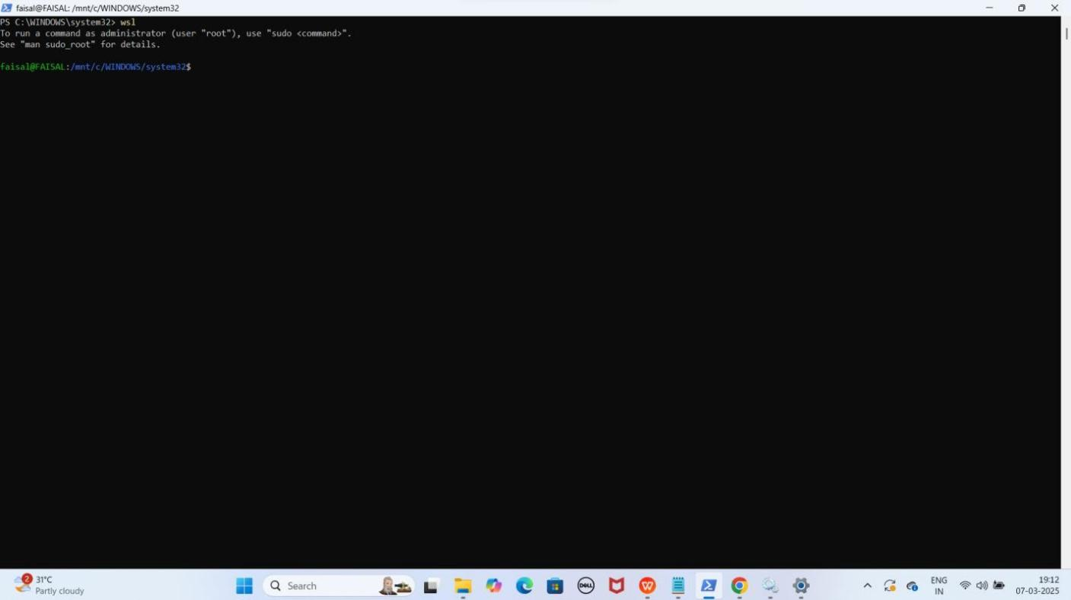

1. **Install karne ke liye ye commands run kariye**

sudo apt-get update

YE KUCH ISTARHA LAGEGA

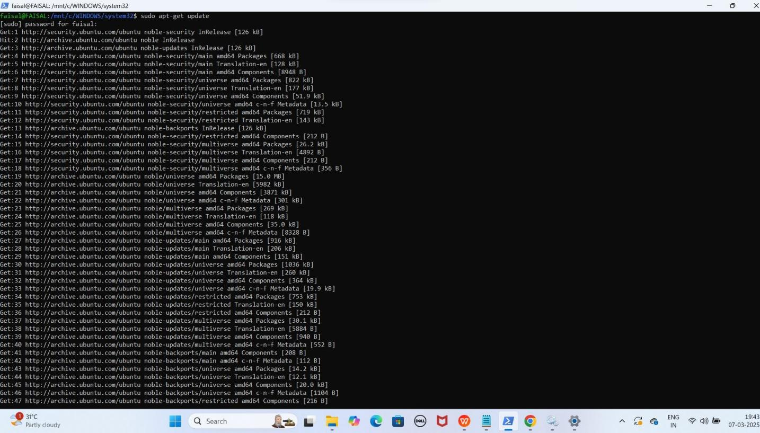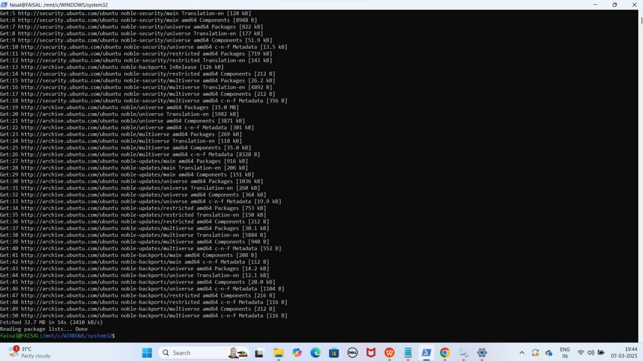

sudo apt-get install apt-transport-https ca-certificates curl software-properties-common

YE KUCH ISTARHA LAGEGA

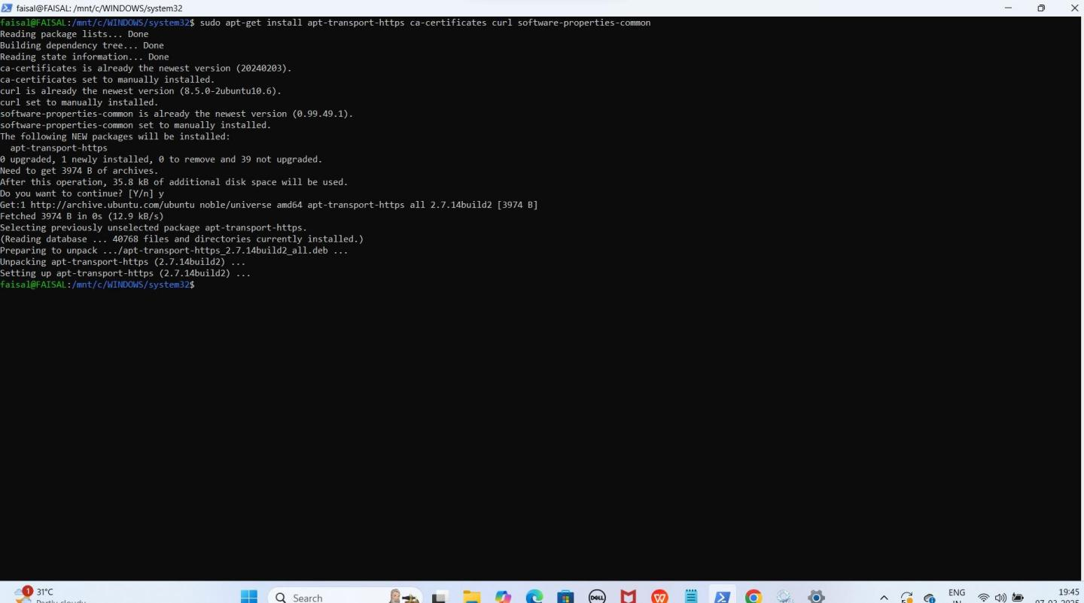

curl -fsSL https://download.docker.com/linux/ubuntu/gpg | sudo apt-key add -

YE KUCH ISTARHA LAGEGA

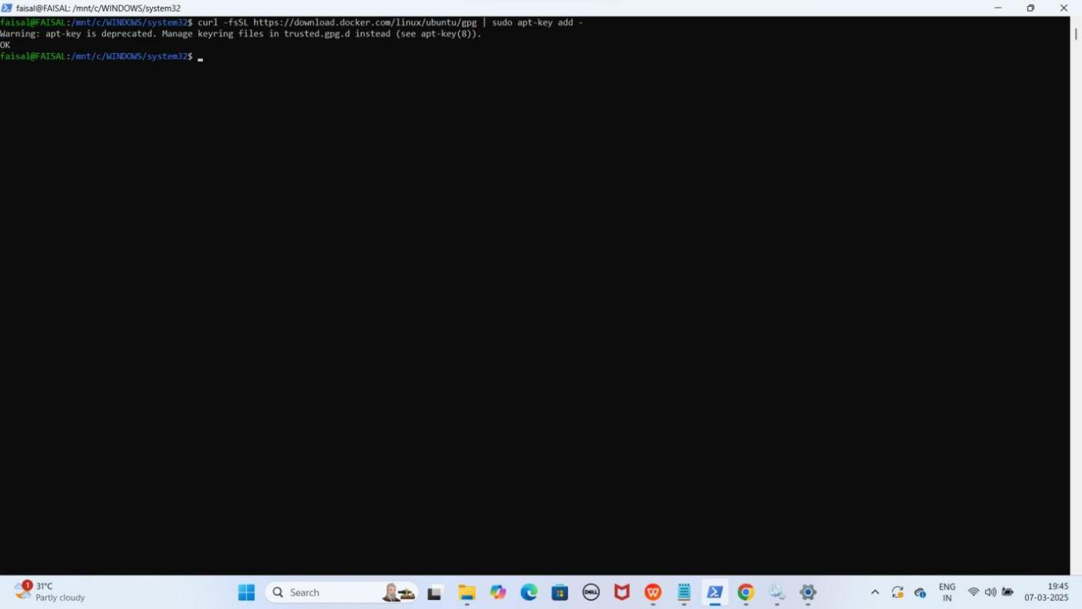

sudo add-apt-repository "deb [arch=amd64] https://download.docker.com/linux/ubuntu $(lsb_release -cs) stable"

YE KUCH ISTARHA LAGEGA

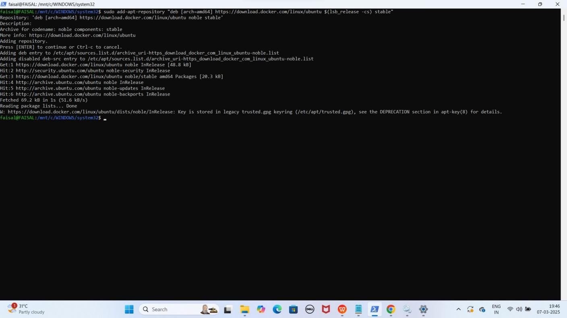

sudo apt-get update

YE KUCH ISTARHA LAGEGA

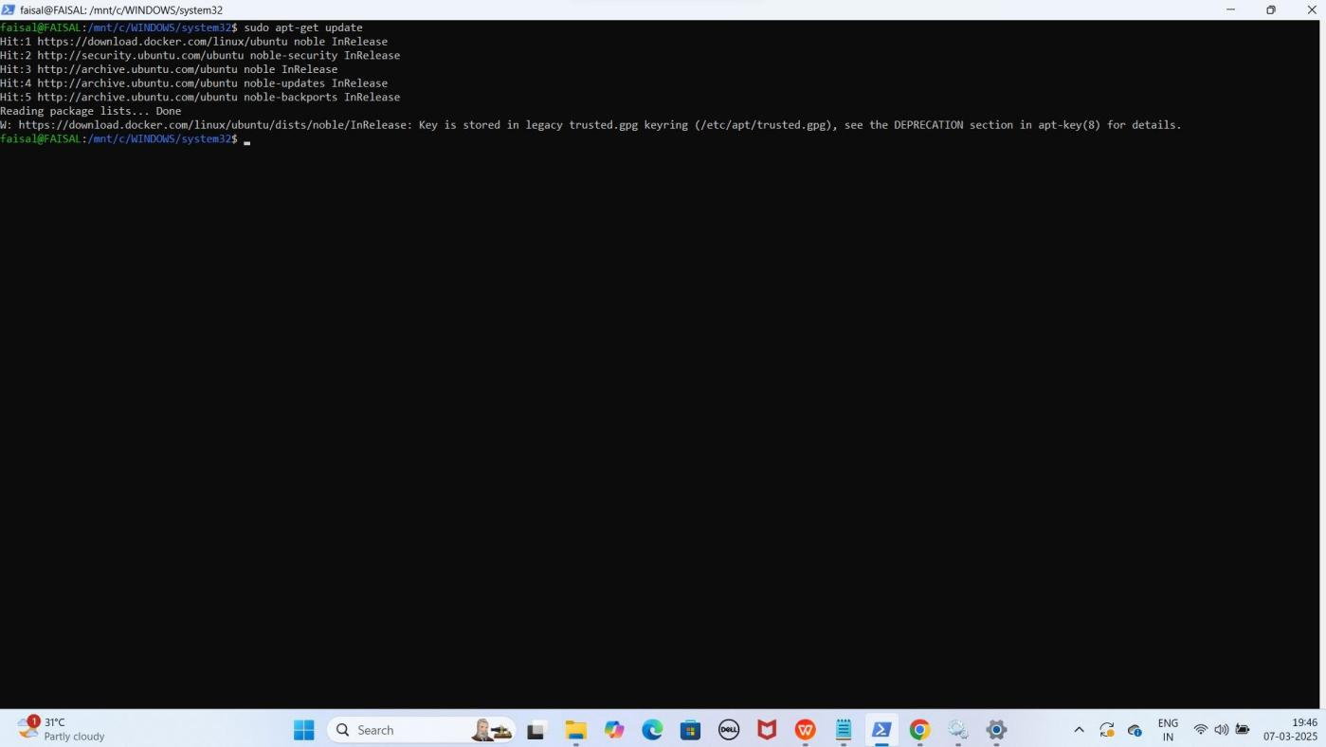

sudo apt-get install docker-ce

YE KUCH ISTARHA LAGEGA

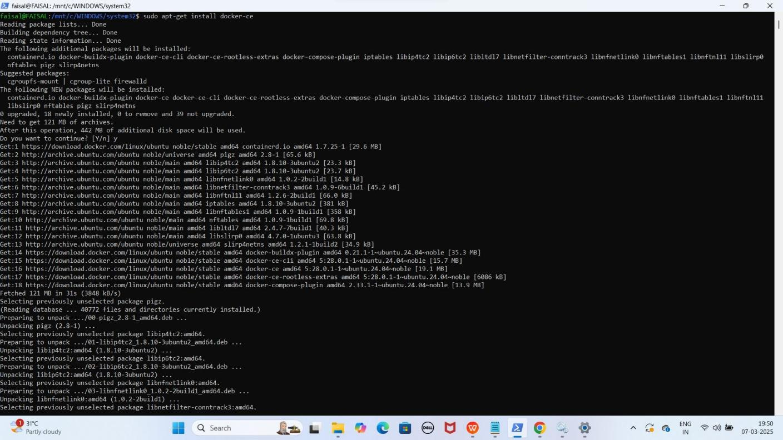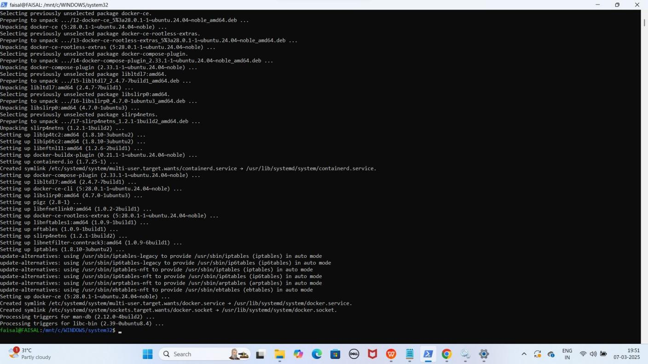

sudo systemctl enable docker YE KUCH ISTARHA LAGEGA

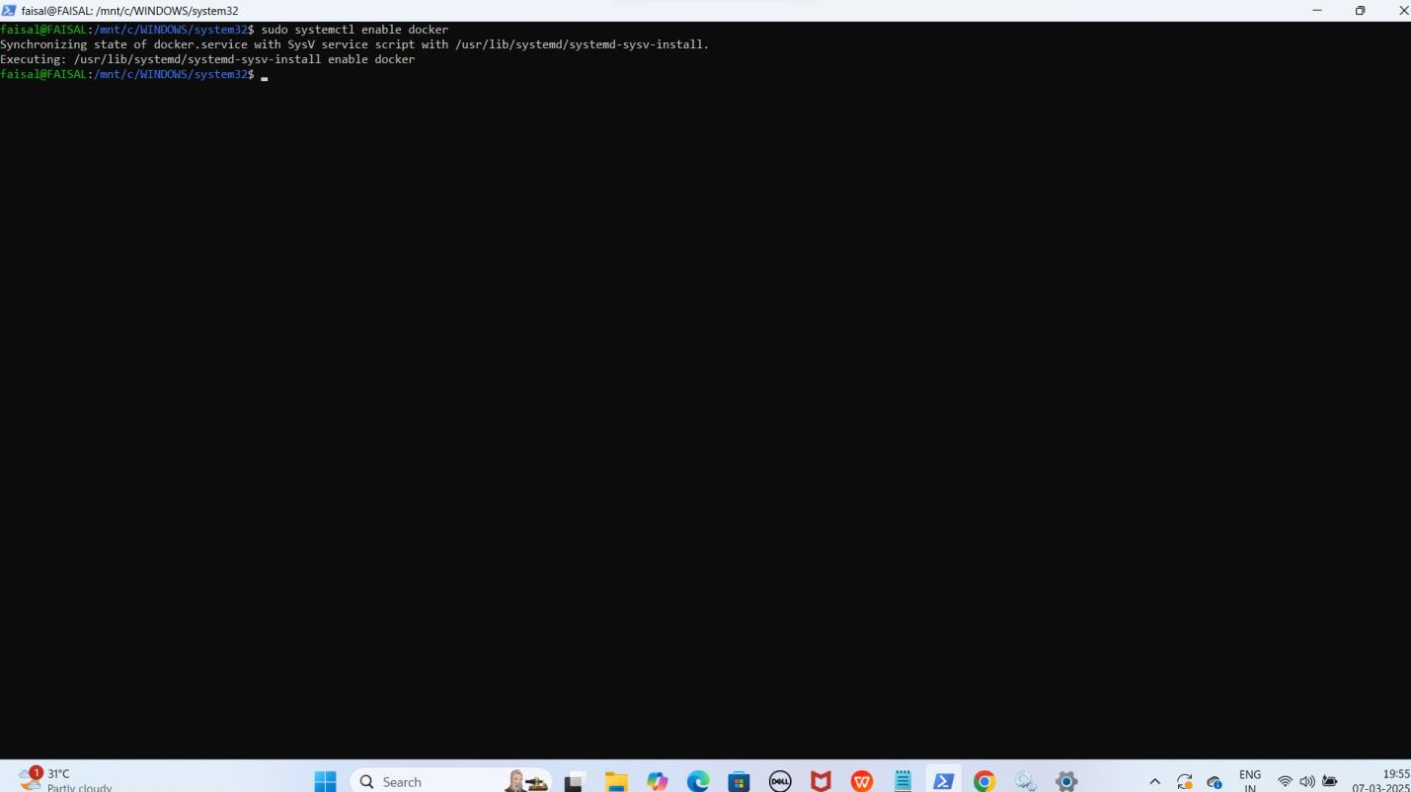

sudo systemctl start docker sudo systemctl status docker YE KUCH ISTARHA LAGEGA

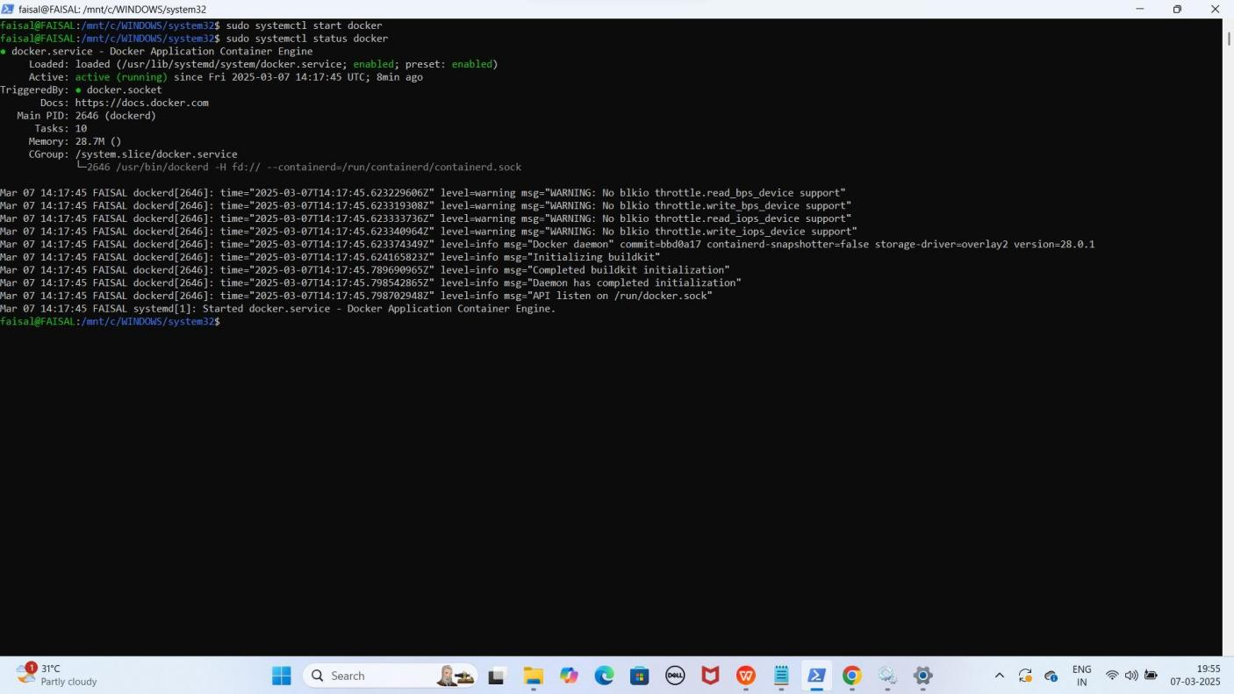

### Step 6: NPM Install Karna WSL ke andar (Future purpose ke liye)

**NPM** ka main **purpose** yeh hai ke aap apne **project** ke liye **JavaScript libraries** aur

**dependencies** ko asani se **install**, **update**, aur **manage** kar sakein.

1. **Install karne ke liye ye commands run kariye**

## sudo apt update && sudo apt install -y npm

YE KUCH ISTARHA LAGEGA

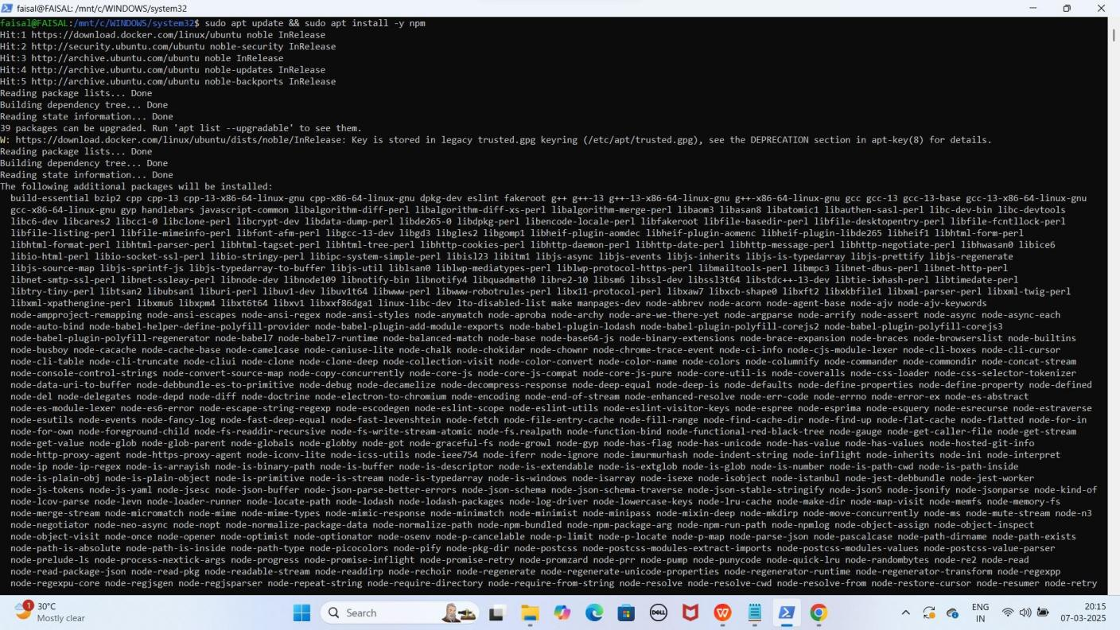

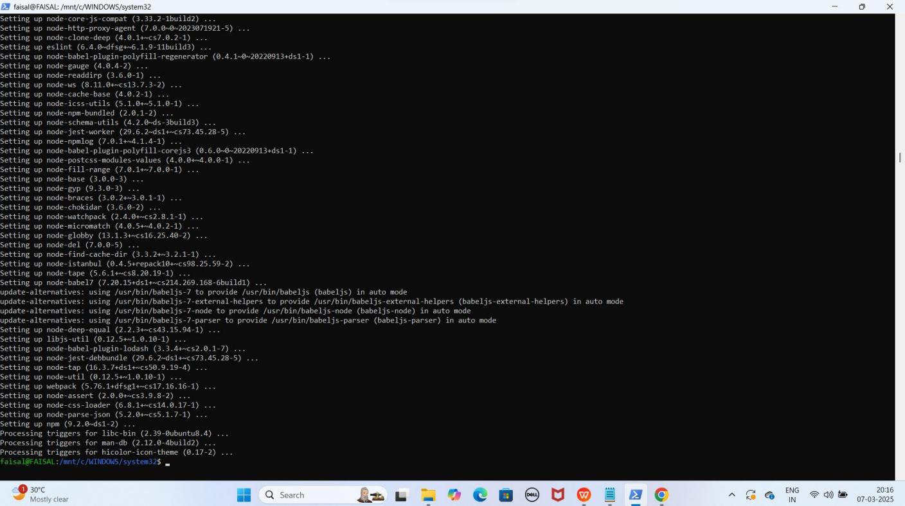

1. **Check karne ke liye NPM install howa hai ye command run kariye**

## npm -v

YE KUCH ISTARHA LAGEGA

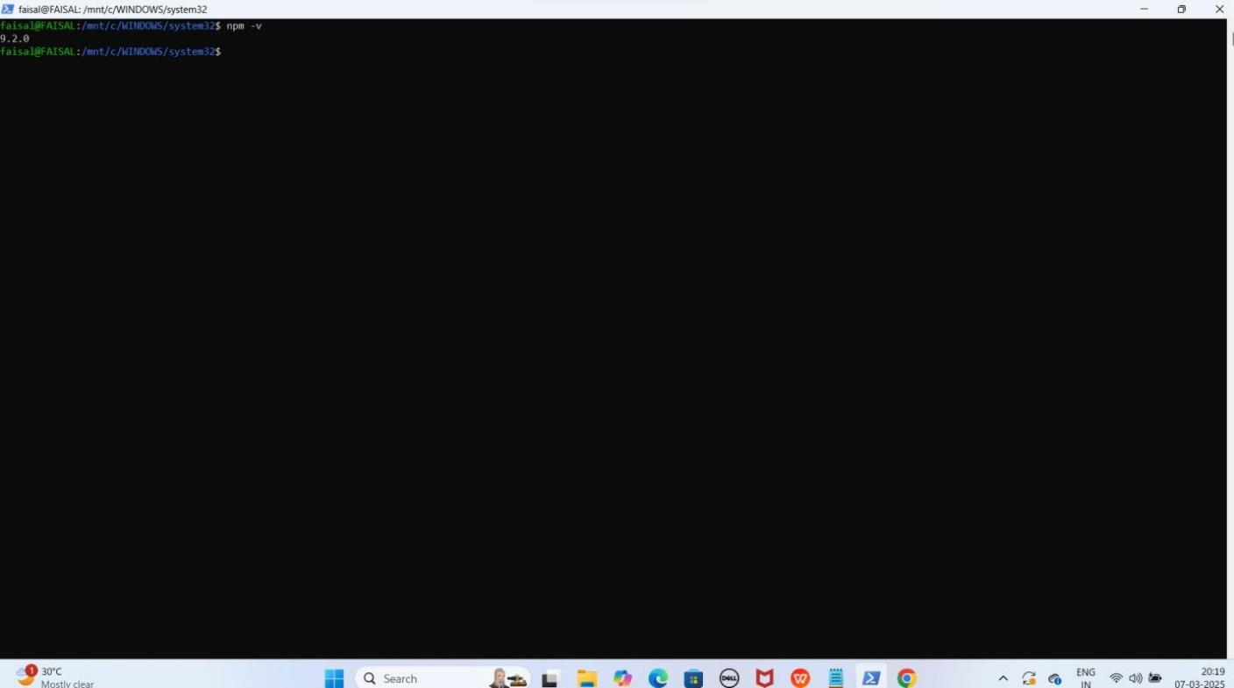

### Step 7: Git Install Karo (Future purpose ke liye)

**Git** ek **version control system (VCS)** hai jo **developers** ko **code** ko **track** karne,

**manage** karne, aur **collaborate** karne me madad karta hai.

1. **Install karne ke liye ye command run kariye**

choco install git -y

YE KUCH ISTARHA LAGEGA

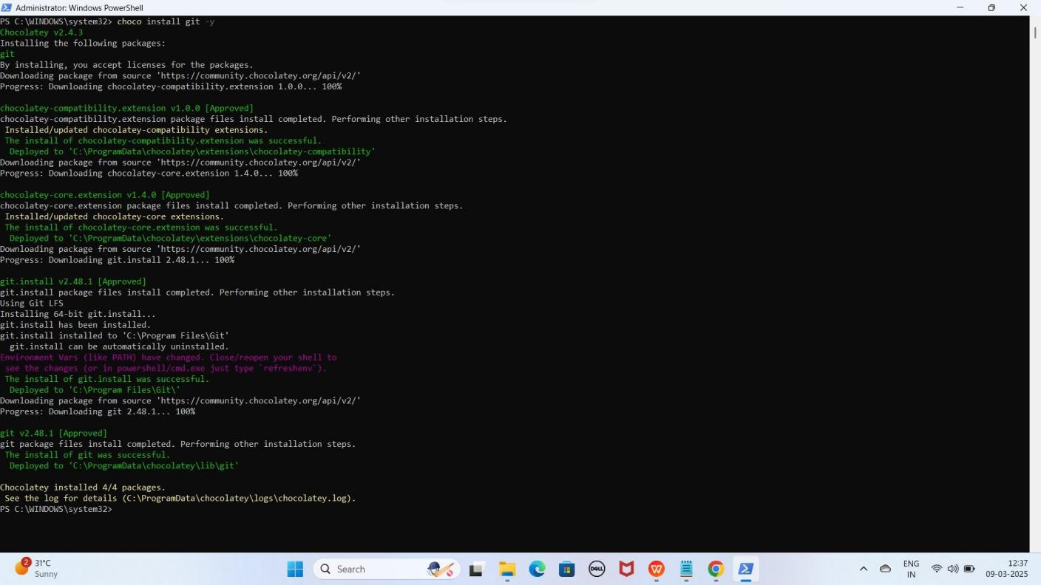

### Step 8: AWS CLI Install Karo

**AWS CLI (Amazon Web Services Command Line Interface)** ek **tool** hai jo command line se **AWS services** ko **manage** karne ke liye use hota hai. Iska matlab hai ke aap **AWS** ke **resources** jaise **EC2, S3, RDS,** aur **IAM users** ko **Local System terminal** se **control** kar sakte ho, bina **AWS Console** open kiye.

1. **Install karne ke liye ye command run kariye**

winget install --id Amazon.AWSCLI -e

YE KUCH ISTARHA LAGEGA

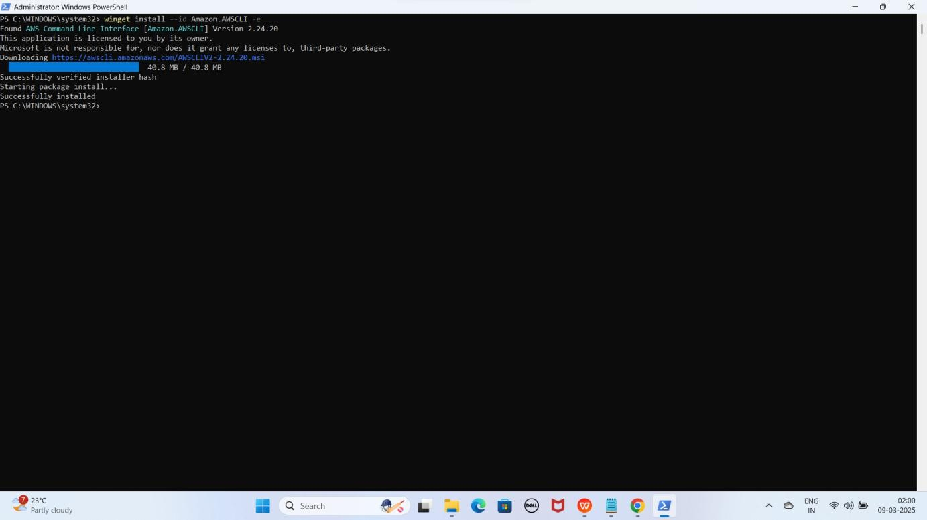

NOTE: AWS CLI install hone ke baad PowerShell ko again Run as Administrator se open karo

1. **AWS CLI Configure karne ke liye ye command run karo PowerShell open hone ke baad**

aws configure

YE KUCH ISTARHA LAGEGA

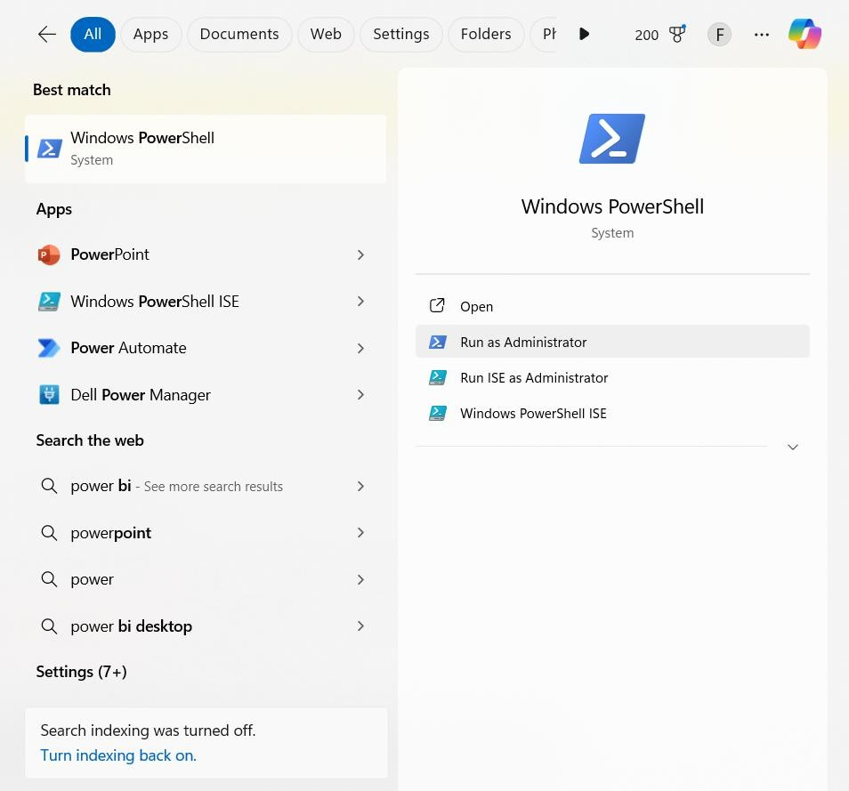

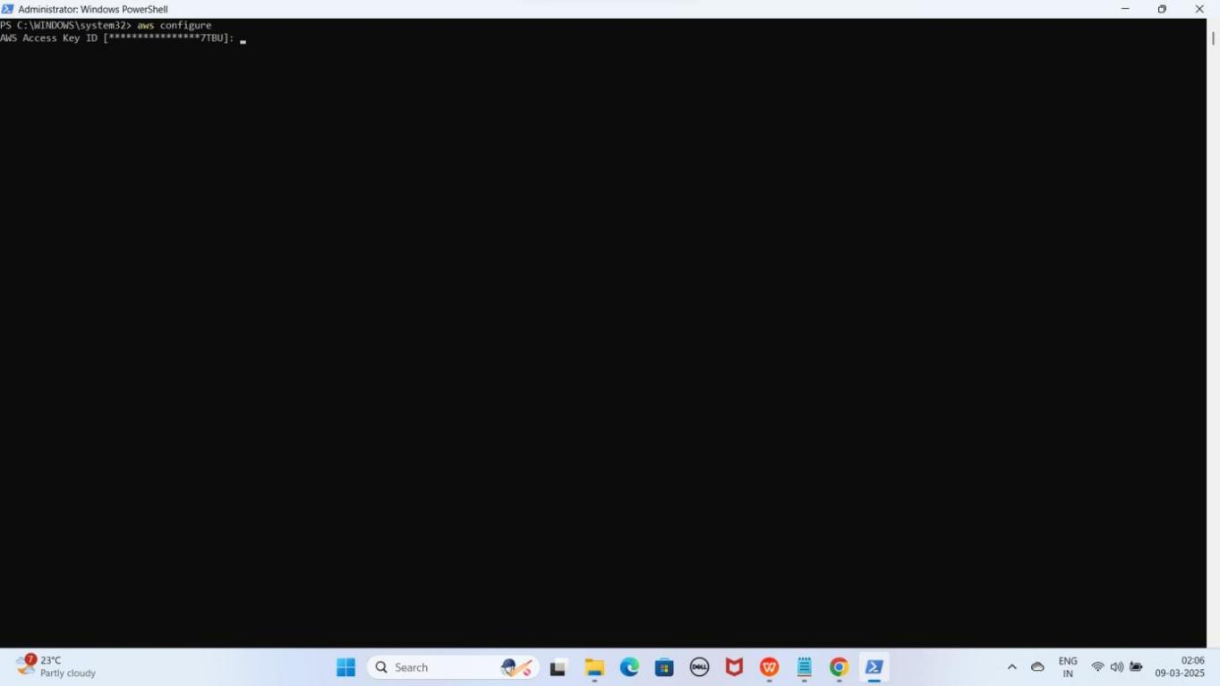

1. **Details Enter Karo**
   * **AWS Access Key ID**: XXXXXXXXXXXXXXXX
   * **AWS Secret Access Key**: XXXXXXXXXXXXXXXXXXXXXX
   * **Default Region**: eu-north-1
   * **Output Format**: text

YE KUCH ISTARHA LAGEGA

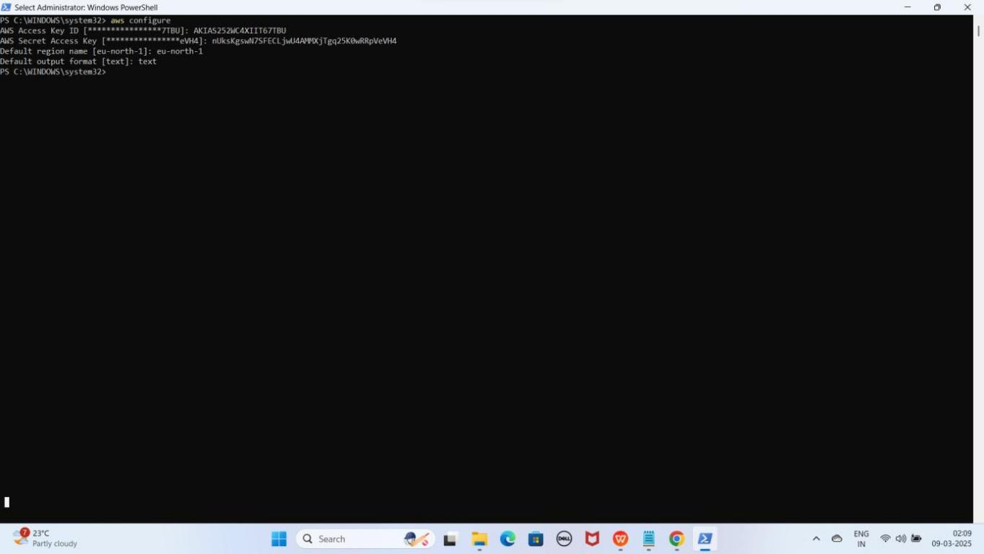

1. **EKS Clsuter se Connect karne ke liye ye command run kariy**

aws eks update-kubeconfig --name Faisal --region eu-north-1

YE KUCH ISTARHA LAGEGA

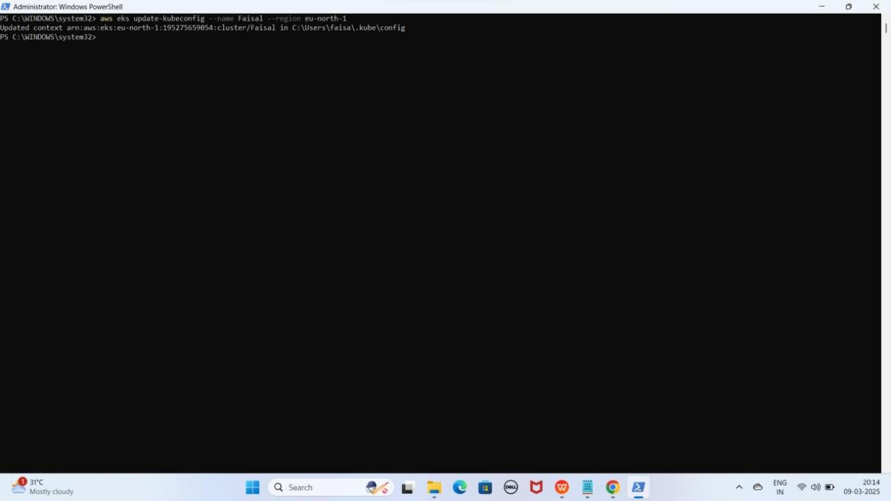

1. **Ab Cluster Nodes check karne ke liye ye command run kare**

kubectl get nodes

YE KUCH ISTARHA LAGEGA

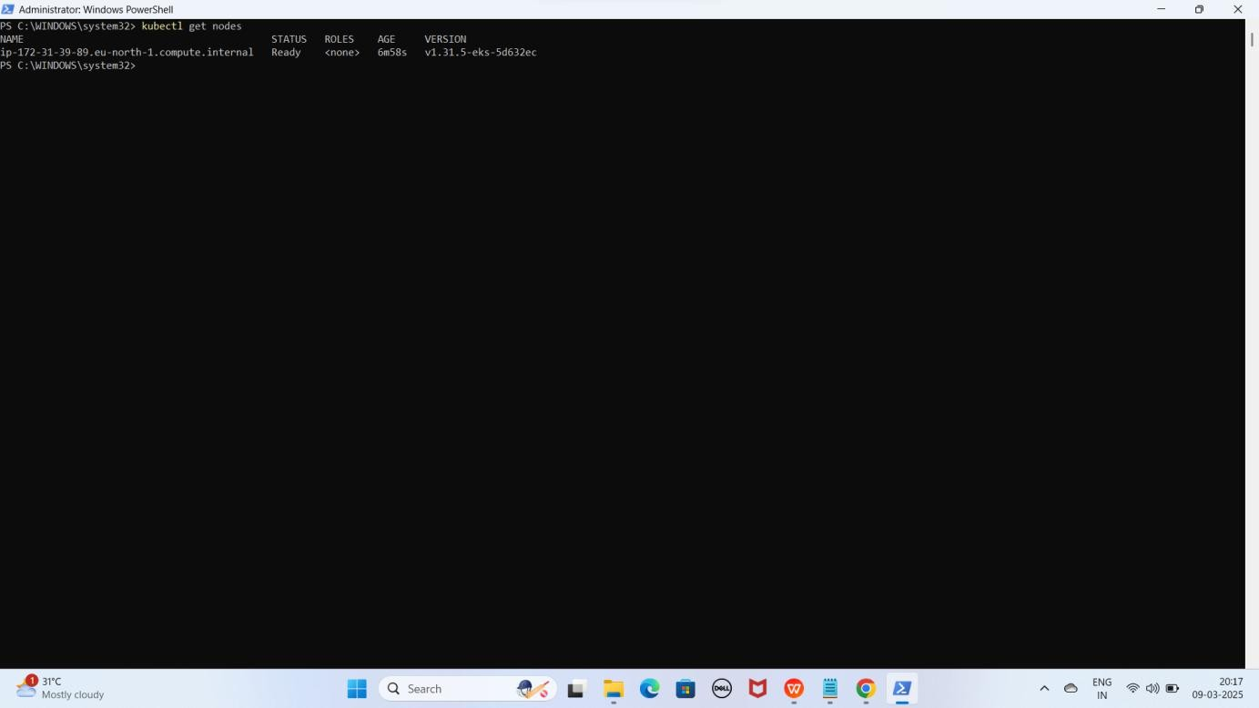

NOTE: Agar STATUS Ready show kar raha hao to Congratulations aapka EKS CLUSTER Successfully Setupand configure hogaya hai ab aap Deployments kar sakte hai

Recommend : Har Step aur Command ko meri Snapshots se Match karein taake Confirm ho sake ke sab kuch sahi tarah se Execute hua hai.

Video Demo : [https://youtu.be/OYhGApMT06o](f)